

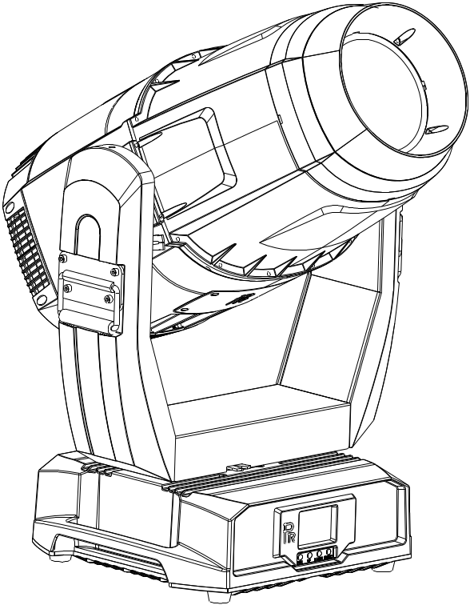

AQUA LED 770-W BWSF

PR-6712

The user manual contains important information about the safe installation and use of a projector. Please read and follow these instructions carefully and keep the manual in a safe place for future reference.

PR LIGHTING LTD.
http://www.pr-lighting.com

INDEX

1. | SAFETY AND WARNINGS…………………………………………………………………………………… | 3
2. | INSTRUCTIONS……………………………………………………………………………………………… | 4
3. | APPEARANCE……………………………………………………………………………………………… | 5
4. | INSTALLATION……………………………………………………………………………………………… | 5
5. | SETUP AND CONFIGURATION……………………………………………………………………………… | 8
6. | OPERATION MENU…………………………………………………………………………………………… | 10
7. | DMX PROTOCOL……………………………………………………………………………………………… | 12
8. | SINGS ON THE TOUCH SCREEN……………………………………………………………………………… | 18
9. | ERROR MESSAGES………………………………………………………………………………………… | 18
10. | TECHNICAL DATA…………………………………………………………………………………………… | 19
11. | CIRCUIT DIAGRAM…………………………………………………………………………………………… | 22
12. | COMPONENT ORDER CODES……………………………………………………………………………… | 24

The following items are supplied with a projector and please check:

Name | Quantity | Unit | Remark
Safety cord | 2 | Pc
User manual | 0 | Pc | QR code
Power Cable | 1 | Pc
XLR connector | 1 | Set | Male and female
G clamps | 2 | pcs
Ω clamps | 2 | pcs | Optional

Please note that as part of our ongoing commitment to continuous product development, specifications are subject to change without notice. Whilst every care is taken in the preparation of the manual we reserve the right to change specifications in the course of product improvement. The publishers cannot be held responsible for the accuracy of the information herein, or any consequence arising from them.
Every unit is tested completely and packed properly by the manufacturer. Please make sure the packing and / or the unit are in good condition before installation and use. Should there be any damage caused by transportation, consult your dealer and do not use the unit. Any damage caused by improper use will not be assumed by the manufacturer and / or dealer.
Note: For the products made by Guangzhou PR lighting Ltd, the warranty for the whole product is one year starting from the delivery date but the light source is not within the warranty.

1. SAFETY AND WARNINGS


NOTE
Before a projector’s installation, power-on, operation and maintenance, please carefully read
the safety information hereinafter!

The following safety signs are used in the user manual.

Warning |   User  Manual | 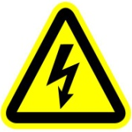  Electrical shock |   Goggles |   Protective Gloves | 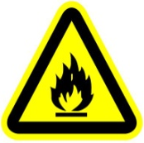  Flames | 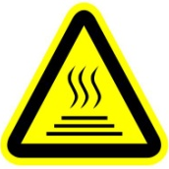  High Temperature

 | ● When unpacking , check if there is any damage caused by transportation before using a projector. Should there be any damage, consult your dealer and do not use it.  ●The manufacture is not responsible for any loss caused by a user not following the manual or changing a projector as he/she likes.  ●Please be noted that any damage caused by changing the projector at will is not warranted.  ● Do not hesitate to contact the dealer or the manufacturer if any questions or advice.
 | ● The projector rated for IP66.  ● The projector can be used in damp, over-heat and over-dusty places.  ● A projector should be kept away from high temperature, fire, electrical surge, vibration and strong light while being operated.  ● A projector is only intended for installation, operation and maintenance by a qualified person. And the operation must strictly follow the procedures in the manual.  ● A projector is not for a user to make any replacements and the user shouldn't open a projector for repair and maintenance.
●Don’t look straightly into the light sources especially for epileptics, otherwise eyes will be burned..
●Do not connect this device to any type of dimmer pack.
● If the light source, lens and screen protective cover of the a projector have obvious damage, i.e., to the extent that it hurts the performance like cracking or deformation, please stop using it and replace them with the original parts, otherwise its performance will be compromised.
● For the location of a projector, it shouldn’t be seen in the distance of less than 4 meters.

 | ●Before operation, please confirm that all covers(housing) are on and screws tightened. It’s forbidden to use a projector while its covers(housing)are off .  ●Keep the light source clean and do not touch it with bare hands.  ●While operating it, wear protective items like goggle and gloves.
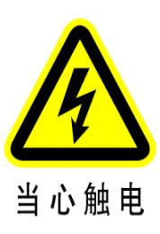 | ●Any electrical connection must be carried out by a qualified person .  ●Before installation, please confirm the voltage supplied matches what is required for a projector.  ●Each projector must be properly earthed and installed as per related electrical standards.  ●Do not use power cord with its insulator damaged and connect the power cord with other cables.  ●If a projector is not used or under cleaning,, please hold its plug and unplug it. Do not unplug it forcefully or by pulling the power cable.  ●All power cords must conform to related safety and regulations.  ●While being operated, if a projector is not waterproof and dust-proof, it should not be under rains or in humidity to avoid being short.  ●Do not switch on and off a projector constantly in very short intervals, otherwise its light source’s and other electrical parts’ life will be shortened .
 | ●There are safety cord holes at the bottom of the base of a projector. In view of safety, please run the safety cord supplied through the safety cord holes for safety support.  ●Before any installation, maintenance and cleaning work, please ensure a projector is disconnected from power mains.
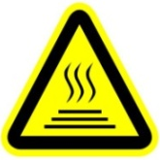 | ●While being in stable working state under normal ambient temperature, the temperature of the surface of the metallic housing of a projector including heat sink will reach 70℃.  ●While its lamp is stricken for the first time, there will be smoke and strange smell. It’s normal and does not mean a projector has some defects.  ●While a projector running, do not touch the metallic housing to avoid being burned.
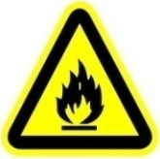 | ●Do not mount a projector directly on inflammable surface.  ●Do not project the beam straightly on combustible items and the minimum distance between it  and illuminated items is 10m.  ●A projector should be installed with good ventilation and the minimum distance between it and walls is 50cm. At the same time, please ensure the fans and air inlets and outlets are workable.  ●Do not let the front lens expose to sunlight or other strong light sources at any angle, otherwise the focused beam inside can result in fire potentially.


● The product meets The General Technical Requirements and Standards for Recycle and Use Of
Expired Appliance and Electronic Products.
● When the product meets disposal standards and needs to be disposed, a client needs to dispose and recycle it.

2. INSTRUCTIONS
●CLEANING AND MAINTENANCE
The accumulation of oil, smoke and dust on the lens will compromise the light output. Cleaning a projector is very necessary to ensure a reliable use of it. The projector is rated for IP66. Unless confirmed by a professional technician for some internal component replacement, it’s forbidden to dismantle a projector.

Cleaning frequency is to be decided by operations and its environment. Use soft cloth and normal detergent for glass for cleaning work. It’s advised external optical system be cleaned every 20days. Keep lens clean and do not touch optical parts with bare hands.

SPECIAL NOTE

While water-proof projectors are in use, it’s normal there will be some minor mist on the front lens.

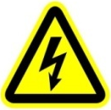 | ● Before any maintenance and cleaning, please ensure a project is off the power.  ● Only a qualified person is allowed to do maintenance.  ● During maintenance and before maintenance, a projector must be off power.
 | ● To avoid sunlight or other light penetrating into the head via the front lens, resulting in high temperature internally causing damages to a projector. Before power-off, please use Tilt channel to move the head and make it facing downward.  ● Do not use alcohol or other organic solvent to clean the housing to avoid damage.  ● Do not use any solvent with chemical elements to clean color filters or hot mirror.

●TROUBLESHOOTING
PROBLEM | ACTION
A projector can’t be switched on | - Check if the fuse is burned  - Check if the power cord is connected well  - Check if the switching power supply is bad or not connected well. A professional technician is required for the repair  - Check if the control board is connected well. .A professional technician is required for the repair
A projector can be switched on , but the LED lamp’s brightness can’t be controlled | - Check if the LED driver board is connected well. A professional technician is required for the repair
A projector can be switched on normally, but not controlled by the DMX controller | - Make sure that its start address is right  - Replace or repair the XLR signal cable.
The beam is not bright and its brightness decreases sharply | - Make sure the fans are working well or fans and their shields are not blocked by dust.  - Make sure that the internal optics are clean.
A project image appears to have a halo | - Carefully clean the LED lamp, optical lenses and other components.
Heavily Defective Beam | - Check if lens are in good condition(not cracked)  - Clean dust or grease on the lens.

3.APPEARANCE
Base
Arm
Body

4. INSTALLATION
●RIGGING
Before moving a projector, Please lock Pan and Tilt. Before its operation, please unlock them. It’s forbidden to run a projector with power while it is locked

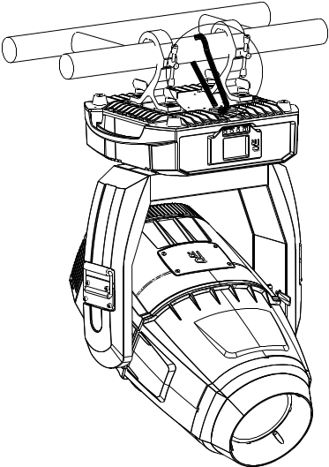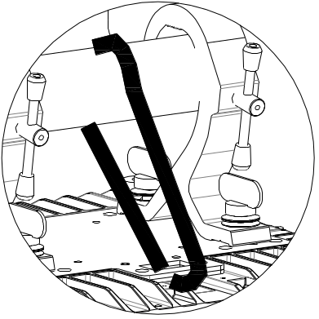
Safety cord
Clamp
Warning!
please run the safety cord through safety cord hole and ensure it is locked well for safety

Take 2 clamps and the safety cord out from the package and mount 2 clamps on the underside of fixture with 2 retainers attached to each clamp. Hang the fixture on the structure and fasten the screws attached to each clamp. (See the WARNING on the underside of the base as shown above) To pass the SAFETY CORD through the HOLES for safety! Always ensure that the projector is firmly anchored to avoid vibration and slipping whilst functioning. Always ensure that the structure that you are going to mount the projector to is secure and strong enough to support the weight of a XR 1000 Framing.

WARNING:
●The projector MUST be lifted or carried by the HANDLES instead of clamps.
●.For safety the safety cord should afford 10 times the Projector’s weight.

● POWER CONNECTION
Connect the power cord as follows:
L (live) =brown
E (earth) =yellow/green
N (neutral) =blue

Before power connection, please ensure the power supplied must match what the nameplate says. It is recommended that each projector be connected with power separately so that they may be individually switched on and off.

●The earth wire(yellow/green) must be connected to the ground. And electrical connection must be in accordance with the standards concerned.
●If any questions about the electrical installation, do not continue but consult a qualified electrician.
●A projector uses naked wires. For wiring please use waterproof junction box with IP class not lower than IP66.

● THE WIRING OF CONTROL SIGNAL

The shielded 2-core wire between a projector and a controller or between projectors should be not less than 0.5mm in diameter and the maximum number of projectors in a DMX chain should be less than 32 pieces.
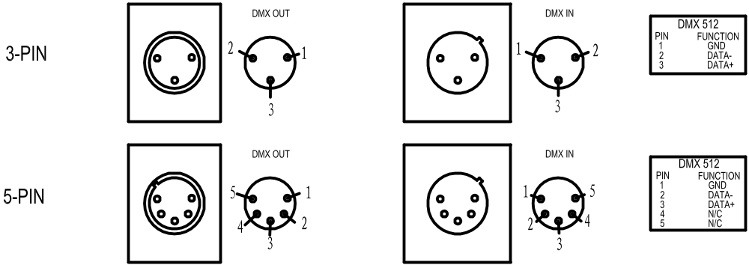
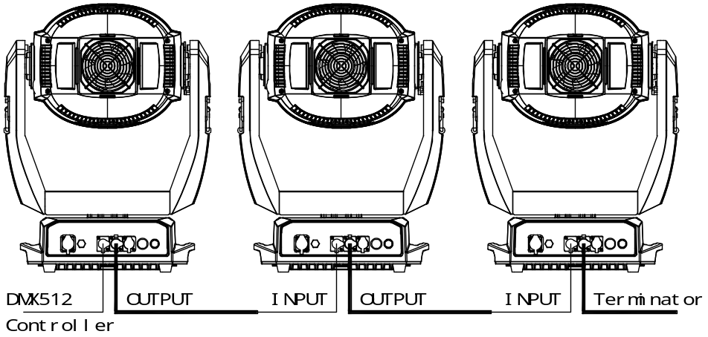

●DMX TERMINATOR

In the Controller mode, at the last fixture in the chain, its female DMX output has to be connected with a DMX terminator.
The DMX terminator is simply a Canon connector with a 120Ω (ohm) resistor connected across pin A+ and pin B-, which prevents electrical noise from disturbing and corrupting the DMX control signals. Before DMX terminator connection, please make proper insulation and waterproof treatment.

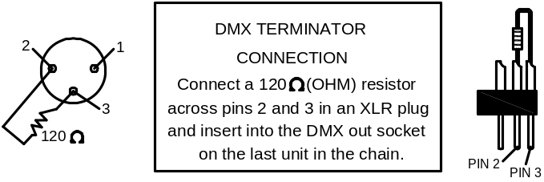

●GOBO FILTER REPLACEMENT
Lock the tilt and loosen the 4 fast-fit screws on the upper cover ,After removing the cover, you will see the structures as the figure above.
To replace a gobo on the rotating gobo wheel: take the rotator from the wheel in the sequence of 1→2 , take the gobo out from the rotator by removing the tightening spring. Put the new gobo back to the rotator, then tighten it with the spring. Please ensure the spring is in the narrow location of the rotator, which is the internal ring of it and flatten it. At last, pull up the spring strip using proper tool and put the rotator back to the wheel with the assistance by another hand. Its installation is of the opposite sequence of removal(（2→1）.

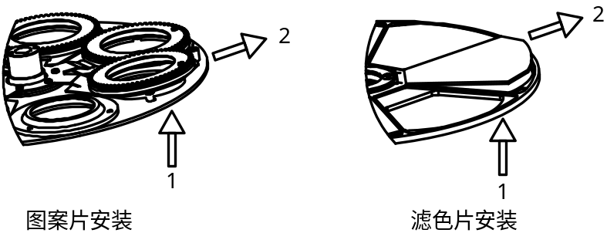

Installation of gobos

NOTE: Do not touch the glass gobo with bare hand. Place clean and soft paper or cloth between hand and glass gobos.
Tighten 4 hexagon screws after the cover is on. Unlock the tilt.

●FIXING THE FRAMING MODULE

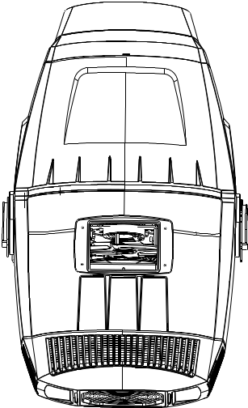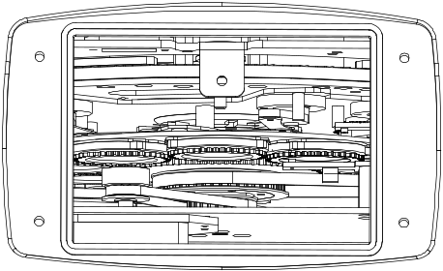
Tightening screw for module rotation
Plug
Note: After the plug unplugged, place it into the hole of the screw for the rotating framing module.

Remove the small cover after locking Tilt after adjusting the framing blades. Unplug the plug on the left after tightening the screw against the module till it can’t move . At last, install the small cover.

If the framing blades need to be adjusted, plug the plug into its original place after loosening the tightening screw, then repeat Step 1.

DANGER!

BEFORE REPLACEMENT OF GOBOS/COLOR FILTERS, A PROJECTOR MUST BE OFF THE POWER!

5.SETUP AND CONFIGURATION

●FRONT PANEL OPERATION

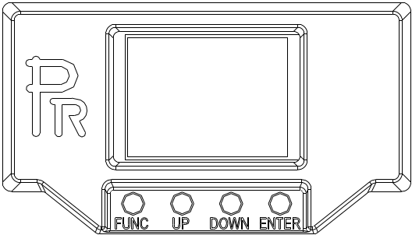

A projector’s configuration can be set conveniently via push button and LCD display.
Launch the projector and press button ENTER for more than 5 seconds to unlock the panel, the LCD will show the function menu of the projector, each main menu has its submenus and each submenu has a specific function. For details, please see the “OPERATION MENU” section.
To set up or browse through its functions, press button UP or DOWN
Press button ENTER to save your settings or enter the submenu.
Press button UP or DOWN to change values(plus or minus)
Press button FUNC, it will return to the upper menu. If button FUNC not pressed, the default will show display status automatically.

● DMX START ADDRESS
Each unit must be given a DMX start address so that the correct projector responds to the correct control signals. This DMX start address is the channel number from which the projector starts to “listen” to the digital control information being sent out from the controller. The unit has 3 DMX modes. There are standard mode ,short mode and extended mode. For example standard mode has 35channels, so set the No. 1 projector’s address 001, No. 2 projector’s address 036, No. 3 projector’s address 071, No. 4 projector’s address106, and so on.
Launch the projector. Press button ENTER more than 5seconds to unlock panel.
Press button ENTER to display DMX address;
Press button UP and DOWN, you can set the address;
Press button ENTER to confirm; after powered on next time, the default will be last value saved
Press button FUNC, it will return to the upper menu
.
●DMX WIRELESS CONTROL (If the projector has the function)
The projector has wireless control function with wireless receiver module and antenna for remote control.
The setup of it is below:
- Enter into the projector’s menu. Select the menu “Config Settigns” via the bottoms of UP and DOWN
- Select DMX control Mode---- Wireless First (Note: do not select XLR ONLY),then wireless indication in the front panel will be on, meaning wireless control function is activated.
Only after the projector is linked with a transmitter, can it receive wireless signal sent by the transmitter. If unlinking it, Press “Enter” for the menu of Unlink Wireless under the upper level menu of Config Settigns .
●STAND-ALONE MODE
Operate the projector without connecting with a controller, enable the master mode through the operation panel, the projector will run in Stand-Alone mode automatically.
DMX address can be set at any number within 512.

●MASTER/SLAVE MODE
Many projectors can run synchronously in the Master/Slave mode by linking them with each other. First,
connect the first fixture’s DMX output to the second fixture’s DMX input using XLR-XLR control cable and then connect the second fixture’s DMX output to the third fixture’s DMX input, and so on until all projector are connected in this way. Eventually connect the last fixture’s DMX output to a DMX terminator. Set 1st projector as the master and others are Slaves. It’s advised that the maximum quantity of projectors in a DMX chain is less than 32.

Start Addresses of all Slaves are 001; Operation mode of the Master can be set any mode for a Master’ and Slaves’ operation mode can be set accordingly.

After Powered on, the group will run in Master/Slave Mode.( The number of projectors in a DMX chain is 32pcs at maximum)

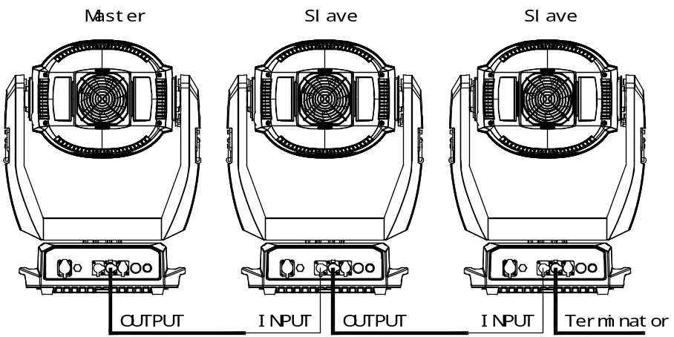

6. OPERATION MENU

1st LEVEL | 2nd LEVEL | 3rd LEVEL | 4th LEVEL | 5th LEVEL
DMX setting | DMX Address | Short Mode:1-481  Standard Mode:1-478  Extended Mode:1-463
DMX setting | IP Address | Default IP Address | 2.X.X.X /10.X.X.X
DMX setting | IP Address | Custom IP Address | X.X.X.X
DMX setting | Sub Net Mask | X.X.X.X
DMX setting | ArtNet Universe | 0-255
DMX setting | sACN Universe | 1-63999
Reset | Total Reset | Really Reset? | Confirm/Cancel
Reset | Pan&Tilt Reset | Really Reset? | Confirm/Cancel
Reset | Colour System Reset | Really Reset? | Confirm/Cancel
Reset | Gobo Reset | Really Reset? | Confirm/Cancel
Reset | Zo.Fo. Fr.Pr. Reset | Really Reset? | Confirm/Cancel
Reset | Other Reset | Really Reset? | Confirm/Cancel
Config Settings | DMX Channel Mode | Short Mode 32CH
Config Settings | DMX Channel Mode | Standard Mode 35CH
Config Settings | DMX Channel Mode | Extended Mode 50CH
Config Settings | DMX Channel Mode | View Mode | 001 Strobe  …
Config Settings | Signal Select | XLR Only
Config Settings | Signal Select | XLR First
Config Settings | Signal Select | Wireless Only
Config Settings | Signal Select | Wireless First
Config Settings | Signal Select | Wireless In/XLR Out
Config Settings | Signal Select | ArtNet Only
Config Settings | Signal Select | ArtNet In/XLR Out
Config Settings | Signal Select | sACN Only
Config Settings | Signal Select | sACN In/XLR Out
Config Settings | Loss of DMX | Normal time out
Config Settings | Loss of DMX | Hold Last Value
Config Settings | Loss of DMX | White Light
Config Settings | Loss of DMX | User Memory 1
Config Settings | Loss of DMX | User Memory 2
Config Settings | Display Config | Display Mode | Off After Delay
Config Settings | Display Config | Display Mode | On Always
Config Settings | Display Config | Display Invert | Invert OFF
Config Settings | Display Config | Display Invert | Invert ON
Config Settings | Display Config | Language Settings | English
Config Settings | Display Config | Language Settings | Chinese
Config Settings | Temperature Unit | Celsius Degree
Config Settings | Temperature Unit | Fahrenheit Degree
Config Settings | Un-Link Wireless | Really Un-Link? | Confirm/Cancel
Config Settings | Defaults | Restore Defaults? | Confirm/Cancel
Option Settings | Pan/Tilt Settings | Pan DMX Invert | OFF/ ON
Option Settings | Pan/Tilt Settings | Tilt DMX Invert | OFF/ ON
Option Settings | Pan/Tilt Settings | Pan Tilt Swap | OFF/ ON
Option Settings | Pan/Tilt Settings | XY Feedback | OFF/ ON
Option Settings | Pan/Tilt Settings | Pan/Tilt Mode | speed/Time
Option Settings | Invert Settings | Dimmer Invert | OFF/ ON
Option Settings | Invert Settings | Zoom Invert | OFF/ ON
Option Settings | Invert Settings | CYM Invert | OFF/ ON
Option Settings | Invert Settings | CTO Invert | OFF/ ON
Option Settings | Dimmer Settings | Gamma Curve | Gamma 2.0/2.2/2.4/2.6
Option Settings | Dimmer Settings | LED Ref. Rate | 1200/2400/4800/10000/12000/15000/20000/25000Hz
Option Settings | Dimmer Settings | Dimmer Speed | Fast/Medium/Slow Speed
Option Settings | Fan Settings | Standard/Theatre
Option Settings | Blade Detect | OFF/ ON
Option Settings | Defaults | Restore Defaults? | Confirm/Cancel
Information | View DMX Values
Information | Total Hours | Reset Total Hours
Information | Temperature | Display Board XX℃/F
Information | Temperature | Driver Board 1 XX℃/F
Information | Temperature | Driver Board 2 XX℃/F
Information | Temperature | Driver Board 3 XX℃/F
Information | Temperature | Fan Board XX℃/F
Information | Temperature | Pan Board XX℃/F
Information | Temperature | Tilt BoardXX℃/F
Information | Temperature | Effect Board XX℃/F
Information | Temperature | LED Sensor XX℃/F
Information | Software Version | Display Board | System= XXX  Boot =XXX
Information | Software Version | Driver Board 1 | System= XXX  Boot =XXX
Information | Software Version | Driver Board 2 | System= XXX  Boot =XXX
Information | Software Version | Driver Board 3 | System= XXX  Boot =XXX
Information | Software Version | Fan Board | System= XXX  Boot =XXX
Information | Software Version | Pan Board | System= XXX  Boot =XXX
Information | Software Version | Tilt Board | System= XXX  Boot =XXX
Information | Software Version | Effect Board | System= XXX  Boot =XXX
Information | Software Version | Led Sensor | System= XXX  Boot =XXX
Information | Electronic SN | Electronic SN=  ************
Information | RDM Device Label | RDM Device Label  ANSI E1.20 RDM
Information | Fan Status | Head Fan
Service | Manual Effect Control | Strobe XXX  Dimmer XXX  ……..
Service | Factory Test
Operation Mode | DMX Mode | Change Operation Mode? | Confirm/Cancel
Operation Mode | Master Mode | Preset Memory | Change Operation Mode? | Confirm/Cancel
Operation Mode | Master Mode | User Memory 1 | Change Operation Mode?
Operation Mode | Master Mode | User Memory 2 | Change Operation Mode?
Operation Mode | Stand-Alone Mode | Preset Memory | Change Operation Mode?
Operation Mode | Stand-Alone Mode | User Memory 1 | Change Operation Mode?
Operation Mode | Stand-Alone Mode | User Memory 2 | Change Operation Mode?
Operation Mode | Static Scene | Change Operation Mode?
User Memories | Edit User Memory | Edit User Memory 1  /Edit User Memory 2 | Scene XX  （1~200Scenes） | Strobe XXX  Dimmer XXX  …….  Delay unit (msec/s/m)  Link to Step XXX
User Memories | Edit User Memory | Edit Static Scene | Strobe XXX  Dimmer XXX  …..
User Memories | Init User Memory | Reset User Memory 1 | Reset User Memory? | Input Password123
User Memories | Init User Memory | Reset User Memory 2 | Reset User Memory? | Input Password123
User Memories | Init User Memory | Reset Static Scene | Reset Static Scene? | Input Password123

7. DMX PROTOCOL

Short mode | Standard mode | Extended mode | Description | Decimal low | Decimal High
1 | 1 | 1 | Strobe
1 | 1 | 1 | Close | 0
1 | 1 | 1 | Pulse strobe from slow to fast | 1 | 127
1 | 1 | 1 | Strobe from slow to fast | 128 | 225
2 | 2 | 2 | Dimmer
2 | 2 | 2 | Close | 0 | 0
2 | 2 | 2 | Linear dimmer (0-100%) | 1 | 255
 | 3 | 3 | Dimmer in 16 bit
 | 3 | 3 | Dimmer in 16 bit adjustment | 0 | 255
3 | 4 | 4 | CYM macros
 |  |  | The following functions will disable CMY,CTO, color wheel
 |  |  | No function | 0 | 7
 |  |  | Color macro1 | 8 | 9
 |  |  | Color macro2 | 10 | 11
 |  |  | Color macro3 | 12 | 13
 |  |  | Color macro4 | 14 | 15
 |  |  | Color macro5 | 16 | 17
 |  |  | Color macro6 | 18 | 19
 |  |  | Color macro7 | 20 | 21
 |  |  | Color macro8 | 22 | 23
 |  |  | Color macro9 | 24 | 25
 |  |  | Color macro10 | 26 | 27
 |  |  | Color macro11 | 28 | 29
 |  |  | Color macro12 | 30 | 31
 |  |  | Color macro13 | 32 | 33
 |  |  | Color macro14 | 34 | 35
 |  |  | Color macro15 | 36 | 37
 |  |  | Color macro16 | 38 | 39
 |  |  | Color macro17 | 40 | 41
 |  |  | Color macro18 | 42 | 43
 |  |  | Color macro19 | 44 | 45
 |  |  | Color macro20 | 46 | 47
 |  |  | Color macro21 | 48 | 49
 |  |  | Color macro22 | 50 | 51
 |  |  | Color macro23 | 52 | 53
 |  |  | Color macro24 | 54 | 55
 |  |  | Color macro25 | 56 | 57
 |  |  | Color macro26 | 58 | 59
 |  |  | Color macro27 | 60 | 61
 |  |  | Color macro28 | 62 | 63
 |  |  | Color macro29 | 64 | 65
 |  |  | Color macro30 | 66 | 67
 |  |  | Color macro31 | 68 | 69
 |  |  | Color macro32 | 70 | 71
 |  |  | Color macro33 | 72 | 73
 |  |  | Color macro34 | 74 | 75
 |  |  | Color macro35 | 76 | 77
 |  |  | Color macro36 | 78 | 79
 |  |  | Color macro37 | 80 | 81
 |  |  | Color macro38 | 82 | 83
 |  |  | Color macro39 | 84 | 85
 |  |  | Color macro40 | 86 | 87
 |  |  | Color macro41 | 88 | 89
 |  |  | Color macro42 | 90 | 91
 |  |  | Color macro43 | 92 | 93
 |  |  | Color macro44 | 94 | 95
 |  |  | Color macro45 | 96 | 97
 |  |  | Color macro46 | 98 | 99
 |  |  | Color macro47 | 100 | 101
 |  |  | Color macro48 | 102 | 103
 |  |  | Color macro49 | 104 | 105
 |  |  | Color macro50 | 106 | 107
 |  |  | Color macro51 | 108 | 109
 |  |  | Color macro52 | 110 | 111
 |  |  | Color macro53 | 112 | 113
 |  |  | Color macro54 | 114 | 115
 |  |  | Color macro55 | 116 | 117
 |  |  | Color macro56 | 118 | 119
 |  |  | Color macro57 | 120 | 121
 |  |  | Color macro58 | 122 | 123
 |  |  | Color macro59 | 124 | 125
 |  |  | Color macro60 | 126 | 127
 |  |  | Color macro61 | 128 | 129
 |  |  | Color macro62 | 130 | 131
 |  |  | Color macro63 | 132 | 133
 |  |  | Color macro64 | 134 | 135
 |  |  | Color macro65 | 136 | 137
 |  |  | Color macro66 | 138 | 139
 |  |  | Color macro67 | 140 | 141
 |  |  | Color macro68 | 142 | 143
 |  |  | Color macro69 | 144 | 145
 |  |  | Color macro70 | 146 | 147
 |  |  | Color macro71 | 148 | 149
 |  |  | Color macro72 | 150 | 151
 |  |  | Color macro73 | 152 | 153
 |  |  | Color macro74 | 154 | 155
 |  |  | Color macro75 | 156 | 157
 |  |  | Color macro76 | 158 | 159
 |  |  | Color macro77 | 160 | 161
 |  |  | Color macro78 | 162 | 163
 |  |  | Color macro79 | 164 | 165
 |  |  | Color macro80 | 166 | 167
 |  |  | Color macro81 | 168 | 169
 |  |  | Color macro82 | 170 | 171
 |  |  | Color macro83 | 172 | 173
 |  |  | Color macro84 | 174 | 175
 |  |  | Color macro85 | 176 | 177
 |  |  | Color macro86 | 178 | 179
 |  |  | Color macro87 | 180 | 181
 |  |  | Color macro88 | 182 | 183
 |  |  | Color macro89 | 184 | 185
 |  |  | Color macro90 | 186 | 187
 |  |  | Color macro91 | 188 | 189
 |  |  | Color macro92 | 190 | 191
 |  |  | Color macro93 | 192 | 193
 |  |  | Color macro94 | 194 | 195
 |  |  | Color macro95 | 196 | 197
 |  |  | Color macro96 | 198 | 199
 |  |  | CMY color mixing fade from slow toast | 200 | 255
4 | 5 | 5 | Cyan
4 | 5 | 5 | Cyan (Linear 0-100%) | 0 | 255
 |  | 6 | Cyan in 16 bit
 |  | 6 | Cyan 16 bit adjustment | 0 | 255
5 | 6 | 7 | Yellow
5 | 6 | 7 | Yellow (Linear 0-100%) | 0 | 255
 |  | 8 | Yellow in 16 bit
 |  | 8 | Yellow 16bit adjustment | 0 | 255
6 | 7 | 9 | Magenta
6 | 7 | 9 | Magenta (Linear 0-100%) | 0 | 255
 |  | 10 | Magenta in 16bit
 |  | 10 | Magenta 16 bit adjustment | 0 | 255
7 | 8 | 11 | CTO
7 | 8 | 11 | Linear CTO from high t low | 0 | 255
 |  | 12 | CTO in 16 bit
 |  | 12 | CTO 16 bit adjustment | 0 | 255
8 | 9 | 13 | Color wheel
8 | 9 | 13 | Continuous positioning
8 | 9 | 13 | Indexing 0-360° | 0 | 63
8 | 9 | 13 | Positioning
8 | 9 | 13 | Open /Color1 | 64 | 67
8 | 9 | 13 | Color 1 | 68 | 71
8 | 9 | 13 | Color1/Color2 | 72 | 75
8 | 9 | 13 | Color2 | 76 | 79
8 | 9 | 13 | Color2/Color3 | 80 | 83
8 | 9 | 13 | Color3 | 84 | 87
8 | 9 | 13 | Color3/Color4 | 88 | 91
8 | 9 | 13 | Color4 | 92 | 95
8 | 9 | 13 | Color4/Color5 | 96 | 99
8 | 9 | 13 | Color5 | 100 | 103
8 | 9 | 13 | Color5/Color6 | 104 | 107
8 | 9 | 13 | Color6 | 108 | 111
8 | 9 | 13 | Color6 /Color7 | 112 | 115
8 | 9 | 13 | Color7 | 116 | 119
8 | 9 | 13 | Color7 /Open | 120 | 123
8 | 9 | 13 | Open | 124 | 127
8 | 9 | 13 | Clockwise rainbow effect from slow to fast | 128 | 191
8 | 9 | 13 | Anti-clockwise rainbow effect from slow to fast | 192 | 255
 | 10 | 14 | Color wheel in 16bit
 | 10 | 14 | Color wheel continuous positioning ,16bit adjustment | 0 | 255
9 | 11 | 15 | Rotating gobo wheel
9 | 11 | 15 | Open | 0 | 15
9 | 11 | 15 | Gobo1 | 16 | 29
9 | 11 | 15 | Gobo2 | 30 | 43
9 | 11 | 15 | Gobo3 | 44 | 57
9 | 11 | 15 | Gobo4 | 58 | 71
9 | 11 | 15 | Gobo5 | 72 | 85
9 | 11 | 15 | Gobo6 | 86 | 99
9 | 11 | 15 | Gobo7 | 100 | 113
9 | 11 | 15 | Gobo8 | 114 | 127
9 | 11 | 15 | Clockwise rotation from slow to fast | 128 | 147
9 | 11 | 15 | Anti-clockwise rotation from slow to fast | 148 | 167
9 | 11 | 15 | Gobo1 shakes from slow to fast | 168 | 178
9 | 11 | 15 | Gobo2 shakes from slow to fast | 179 | 189
9 | 11 | 15 | Gobo3 shakes from slow to fast | 190 | 200
9 | 11 | 15 | Gobo4shakes from slow to fast | 201 | 211
9 | 11 | 15 | Gobo5shakes from slow to fast | 212 | 222
9 | 11 | 15 | Gobo6shakes from slow to fast | 223 | 233
9 | 11 | 15 | Gobo7shakes from slow to fast | 234 | 244
9 | 11 | 15 | Gobo8shakes from slow to fast | 245 | 255
10 | 12 | 16 | Gobo rotation
10 | 12 | 16 | Indexing 0-360° | 0 | 128
10 | 12 | 16 | Clockwise rotation from slow to fast | 129 | 188
10 | 12 | 16 | Stop | 189 | 195
10 | 12 | 16 | Anti-clockwise rotation from slow to fast | 196 | 255
 | 13 | 17 | Gobo rotation in 16bit
 | 13 | 17 | Gobo rotation 16 bit adjustment | 0 | 255
11 | 14 | 18 | Framing blade 1left
11 | 14 | 18 | Linear Framing Blade1 Left Change 0%-100% | 0 | 255
 |  | 19 | Framing Blade 1 Left change in 16 bit
 |  | 19 | Framing Blade 1 Left change in 16 bit precision | 0 | 255
12 | 15 | 20 | Framing Blade 1 right
12 | 15 | 20 | Linear Framing Blade1 Right Change 0%-100% | 0 | 255
 |  | 21 | Framing Blade 1 right change in 16 bit
 |  | 21 | Framing Blade 1 right change in 16 bit precision | 0 | 255
13 | 16 | 22 | Framing Blade 2 Left
13 | 16 | 22 | Linear Framing Blade2 Left Change 0%-100% | 0 | 255
 |  | 23 | Framing Blade 2 Left change in 16 bit
 |  | 23 | Framing Blade 2 Left change in 16 bit precision | 0 | 255
14 | 17 | 24 | Framing Blade 2 Right
14 | 17 | 24 | Linear Framing Blade2 Right Change 0%-100% | 0 | 255
 |  | 25 | Framing Blade 2 right change in 16 bit
 |  | 25 | Framing Blade 2 right change in 16 bit precision | 0 | 255
15 | 18 | 26 | Framing Blade 3 Left
15 | 18 | 26 | Linear Framing Blade3 Left Change 0%-100% | 0 | 255
 |  | 27 | Framing Blade 3 Left change in 16 bit
 |  | 27 | Framing Blade 3Left change in 16 bit precision | 0 | 255
16 | 19 | 28 | Framing Blade 3 Right
16 | 19 | 28 | Linear Framing Blade3 Right Change 0%-100% | 0 | 255
 |  | 29 | Framing Blade 3 right change in 16 bit
 |  | 29 | Framing Blade 3right change in 16 bit precision | 0 | 255
17 | 20 | 30 | Framing Blade 4 Left
17 | 20 | 30 | Linear Framing Blade4Left Change 0%-100% | 0 | 255
 |  | 31 | Framing Blade 4 Left change in 16 bit
 |  | 31 | Framing Blade 4Left change in 16 bit precision | 0 | 255
18 | 21 | 32 | Framing Blade 4 Right
18 | 21 | 32 | Linear Framing Blade4Right Change 0%-100% | 0 | 255
 |  | 33 | Framing Blade 4 right change in 16 bit
 |  | 33 | Framing Blade 4right change in 16 bit precision | 0 | 255
19 | 22 | 34 | Framing Module rotation
19 | 22 | 34 | Framing Module Indexing(0-90degrees) | 0 | 255
 |  | 35 | Framing Module rotation in 16 bit
 |  | 35 | Framing Module rotation(0-90degrees) in 16 bit | 0 | 255
20 | 23 | 36 | Prism
20 | 23 | 36 | No | 0 | 16
20 | 23 | 36 | Prism in | 17 | 255
21 | 24 | 37 | Prism rotation
21 | 24 | 37 | Prism indexing | 0 | 127
21 | 24 | 37 | Stop | 128
21 | 24 | 37 | Clockwise rotation from slow to fast | 129 | 191
21 | 24 | 37 | Stop | 192
21 | 24 | 37 | Anti-clockwise rotation from slow to fast | 193 | 255
22 | 25 | 38 | Effect wheel
22 | 25 | 38 | No | 0 | 19
22 | 25 | 38 | Effect wheel in | 20 | 255
23 | 26 | 39 | Effect wheel rotation
23 | 26 | 39 | Clockwise rotation from fast to slow | 0 | 127
23 | 26 | 39 | Anti-clockwise rotation from slow to fast | 128 | 255
24 | 27 | 40 | Frost
24 | 27 | 40 | Linear frost 0% - 100% | 0 | 255
25 | 28 | 41 | Focus
25 | 28 | 41 | Linear focus | 0 | 255
 |  | 42 | Focus in 16 bit
 |  | 42 | Focus 16 bit adjustment | 0 | 255
26 | 29 | 43 | Zoom
26 | 29 | 43 | Linear Zoom | 0 | 255
 |  | 44 | Zoom in 16 bit
 |  | 44 | Zoom 16 bit adjustment | 0 | 255
27 | 30 | 45 | Pan
27 | 30 | 45 | Pan Movement | 0 | 255
28 | 31 | 46 | Pan Fine
28 | 31 | 46 | Pan in 16 bit | 0 | 255
29 | 32 | 47 | Tilt
29 | 32 | 47 | Tilt Movement | 0 | 255
30 | 33 | 48 | Tilt Fine
30 | 33 | 48 | Tilt in 16 bit | 0 | 255
31 | 34 | 49 | Pan and Tilt Speed
31 | 34 | 49 | Fast speed mode | 0 | 1
31 | 34 | 49 | Speed from fast to slow | 2 | 255
32 | 35 | 50 | Power/Special function
32 | 35 | 50 | No function | 0 | 4
32 | 35 | 50 | Reserved | 5 | 19
32 | 35 | 50 | The following function must stay in the DMX range for more than 5s to activate it
32 | 35 | 50 | Display on | 20 | 24
32 | 35 | 50 | Display off | 25 | 29
32 | 35 | 50 | Reserved | 30 | 44
32 | 35 | 50 | Reserved | 45 | 46
32 | 35 | 50 | Fan standard mode | 47 | 48
32 | 35 | 50 | Fan theater mode | 49 | 50
32 | 35 | 50 | Reserved | 51 | 52
32 | 35 | 50 | Fast dimmer speed | 53 | 54
32 | 35 | 50 | Medium dimmer speed | 55 | 56
32 | 35 | 50 | Slow dimmer speed | 57 | 58
32 | 35 | 50 | Gamma curve 2.0 | 59 | 60
32 | 35 | 50 | Gamma curve 2.2 | 61 | 62
32 | 35 | 50 | Gamma curve 2.4 | 63 | 64
32 | 35 | 50 | Gamma curve 2.6 | 65 | 66
32 | 35 | 50 | LED fresh rate 1200Hz | 67 | 68
32 | 35 | 50 | LED refresh rate 2400Hz | 69 | 70
32 | 35 | 50 | LED refresh rate 4800Hz | 71 | 72
32 | 35 | 50 | LED refresh rate 10000Hz | 73 | 74
32 | 35 | 50 | LED refresh rate 12000Hz | 75 | 76
32 | 35 | 50 | LED refresh rate 15000Hz | 77 | 78
32 | 35 | 50 | LED refresh rate 20000Hz | 79 | 80
32 | 35 | 50 | LED refresh rate 25000Hz | 81 | 82
32 | 35 | 50 | Reserved | 83 | 149
32 | 35 | 50 | Color system reset | 150 | 159
32 | 35 | 50 | Gobo wheel reset | 160 | 169
32 | 35 | 50 | Reserved | 170 | 179
32 | 35 | 50 | Zoom/Focus/Frost/Prism reset | 180 | 189
32 | 35 | 50 | Other（effect wheel, framing module）reset | 190 | 199
32 | 35 | 50 | Total reset | 200 | 209
32 | 35 | 50 | Reserved | 210 | 255

Remarks:
Fan errors can result in LED lamp off automatically

8. SIGNS OF THE TOUCH SCREEN

 | Config Settings |  | Option Settings
 | Error Messages |  | Information
 | Address |  | Service
 | Reset |  | Operation Mode
 | User Memories

9. ERROR MESSAGE
The system can detect some errors during the reset, if displayed, press to view the error.
The error messages are as follows:

Name | Type | Correction
Pan | Timeout/magnetSensor/Encoder | Check if wiring, positioning parts and motors are normal
Tilt | Timeout/magnetSensor/Encoder | Check if wiring, positioning parts and motors are normal
Cyan | Timeout | Check if wiring, positioning parts and motors are normal
Yellow | Timeout | Check if wiring, positioning parts and motors are normal
Magenta | Timeout | Check if wiring, positioning parts and motors are normal
CTO | Timeout | Check if wiring, positioning parts and motors are normal
Color Wheel | Timeout | Check if wiring, positioning parts and motors are normal
Rot. Gobo Wheel | Timeout | Check if wiring, positioning parts and motors are normal
Rot. Gobo Rotation | Timeout | Check if wiring, positioning parts and motors are normal
Dimmer | Timeout | Check if wiring, positioning parts and motors are normal
Prism | Timeout | Check if wiring, positioning parts and motors are normal
Prism Rotation | Timeout | Check if wiring, positioning parts and motors are normal
Focus | Timeout | Check if wiring, positioning parts and motors are normal
Zoom | Timeout | Check if wiring, positioning parts and motors are normal
Effect wheel | Timeout | Check if wiring, positioning parts and motors are normal
Effect wheel rotation | Timeout | Check if wiring, positioning parts and motors are normal
Framing module rotation | Timeout | Check if wiring, positioning parts and motors are normal
Driver Board 1 | Error | Check signal wire
Driver Board 2 | Error | Check signal wire
Driver Board 3 | Error | Check signal wire
Framing module board | Error | Check signal wire
Fan Board | Error | Check signal wire
Lamp Off[Fan Error] | Error | Check if all fans are normal
Time IC | Error

10.TECHNICAL DATA
ELECTRIC PARAMETERS
Input voltage: 100V~240V AC，50/60Hz
Input power: 770W@220V AC
790W @ 100V AC
Max. current: 8.0A @ 100V
Power factor PF>0.9

THE SPECIFICATIONS OF THE LIGHT SOURCE
Power 500W White LED
Color temperature 9000K
Rated life 20000hrs
CRI Ra≥70( Option: Ra≥90)
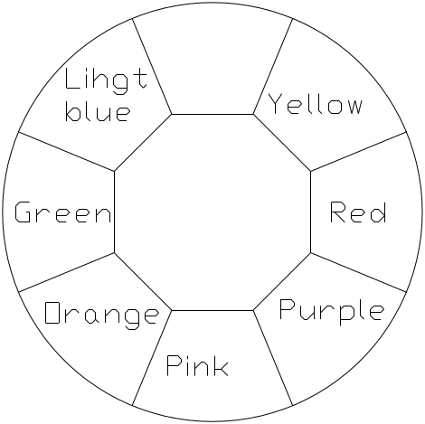
COLORS
CMY linear mixing system with macros
1 color wheel: 7exchangeable colors+ Open
Half color effect, rainbow effect with bi-directional and variable speeds,
Stepping/linear color changing

CTO
0-100% linear CTO

GOBO
1 Rotating Gobo Wheel: 8 replaceable gobos+ Open, Glass or Metal Gobo
Bi-directional Rotation with variable speeds
With Indexing Function
Gobo Shake Effect with Variable Speeds
Bi-directional Scrolling with Variable Speeds
Gobo outer size:24mm Gobo image size: 18mm
1framing module rotates between 0° and 90° and produces graphics of different shapes and sizes
4 framing blades can produce full curtain effect
 |  |  |  | 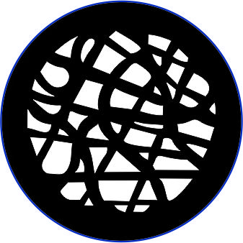
1# | 2# | 3# | 4# | 5#
 |  | 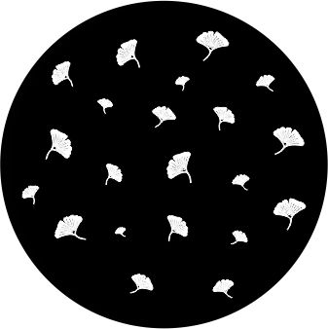
6# | 7# | 8#

PRISM
1pc of 4 facet prism , Bi-directional rotation with variable speeds and indexing function

FROST
1pc frost filter, linear frost effect( 0%-100%)

EFFECT WHEEL
1pc, replaceable, bi-directional rotation with variable speeds

FOCUS
DMX linear Focusing

DIMMER
0-100% Linear adjustment
STROBE
Double shutter blades, 0.3~25 F.P.S

PAN AND TILT MOVEMENT
Tilt 0°~270°
Pan 0°~540°
BEAM ANGLE
linear zoom 5.5°～ 50° with 16 bit function

CONTROL
DMX512, 5 pin interfaces
RDM control protocol
31channels in short mode,35 channels in standard mode and 50 channels in extended mode
Master/Slave synchronized mode
Stand-alone mode
OTHER FUNCTION
Total hours displayable
English and Chinese menus
Built-in sensor diagnostic system
Software versions displayable
Input signal isolation
Modular Structure for easy maintenance
Ethernet Interface
DMX512 wireless reciever

HOUSING
High temperature ABS+ High tensile cast aluminum , IP66
NET WEIGHT
39Kg
OPERATION TEMPERATURE
Highest ambient temperature 45℃
Note: If the ambient temperature is below -20°C, reset a projector before pre-heating it for more than 30 minutes
SIZES (unit: mm)
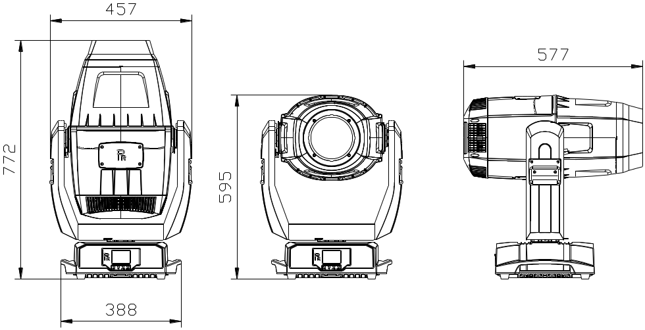

BEAM ANGLE
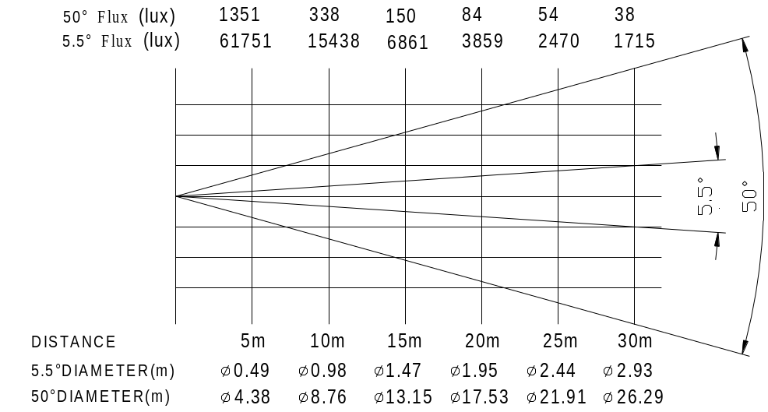

11. CIRCUIT DIAGRAM

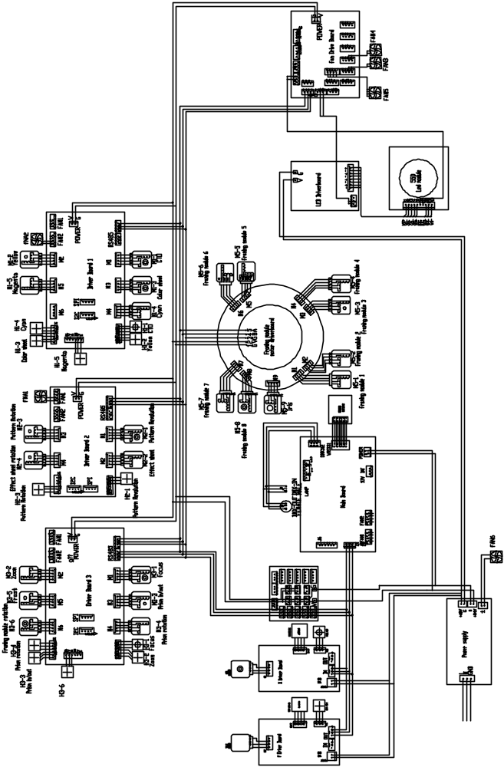
12.COMPONENT ORDER CODES

NAME | CODE NO. | QTY. | REMARKS
SWITCHING POWER SUPPLY | 192010228A | 1
LED MODULE | 150020337 | 1
LED MODULE FAN | 030060116 | 1
BLOWER FOR GOBO WHEEL | 030060106 | 1
FAN FOR POWER SUPPLY IN THE BASE | 030060075 | 1
LED DRIVER FAN | 030060084 | 1
FAN FOR LENS ACCESSORY | 030060104 | 1
BLOWER FOR LENS ACCESSORY | 030060072A | 1
FOCUS MOTOR | 030040213A | 1
ZOOM MOTOR | 030040154A | 1
PRISM IN/OUT MOTOR | 030040132A | 1
PRISM ROTATION MOTOR | 030040203 | 1
FROST MOTOR | 030040220A | 1
ROTATING GOBO WHEEL MOTOR | 030040215A | 1
GOBO ROTATION MOTOR | 030040293 | 1
EFFECT WHEEL IN/OUT MOTOR | 030040081A | 1
EFFECT WHEEL ROTATION MOTOR | 030040254A | 1
COLOR WHEEL MOTOR | 030040154A | 1
PAN MOTOR | 030040246A | 1
TILT MOTOR | 030040278B | 1
CMY MOTOR | 030040211A | 3
CTO MOTOR | 030040211A | 1

PR LIGHTING LTD.

1582 Xingye Avenue, Nancun Panyu
Guangzhou, 511442 China
TEL: +86-20-3995 2888

PR lighting will try its best to offer accurate and overall information about a product’s technical data. Any changes won’t be notified if necessary. Patented Products. Counterfeiting Will be Prosecuted!

P/N: 320021497

Old Version:20221202

New Version:20230104

