

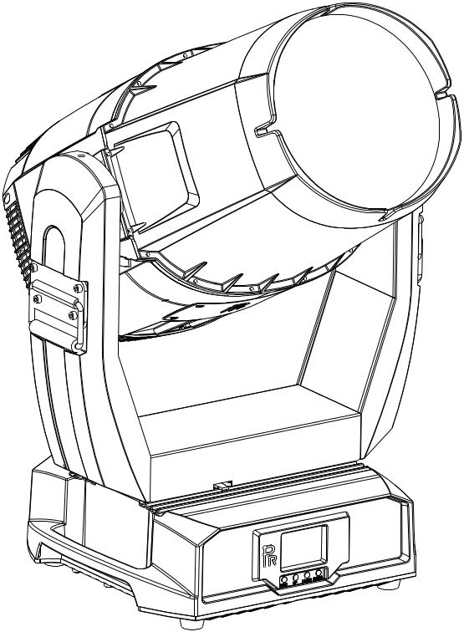

AQUA LASER 260 BEAM

PR-8339

The user manual contains important information about the safe installation and use of a projector. Please read and follow these instructions carefully and keep the manual in a safe place for future reference.

PR LIGHTING LTD.
http://www.pr-lighting.com

INDEX
1. | SAFETY AND WARNINGS…………………………………………………………………………………… | 3
2. | INSTRUCTIONS………………………………………………………………………………………………… | 4
3. | INSTALLATION………………………………………………………………………………………………… | 5
4. | SETUP AND CONFIGURATION………………………………………………………………………………… | 7
5. | OPERATION MENU…………………………………………………………………………………………… | 9
6. | DMX PROTOCOL……………………………………………………………………………………………… | 13
7. | ERROR MESSAGE…………………………………………………………………………………………… | 17
8. | TECHNICAL DATA…………………………………………………………………………………………… | 18
9.  10. | CIRCUIT DIAGRAM……………………………………………………………………………………………  COMPONENT ORDER CODES………………………………………………………………………………… | 21  23

ACCESSORIES
The following items are supplied with the projector and please check:

Name | Quantity | Unit | Remark
Safety cord | 1 | Pc
User manual | 1 | Pc

Please note that as part of our ongoing commitment to continuous product development, specifications are subject to change without notice. Whilst every care is taken in the preparation of the manual we reserve the right to change specifications in the course of product improvement. The publishers cannot be held responsible for the accuracy of the information herein, or any consequence arising from them.
Every unit is tested completely and packed properly by the manufacturer. Please make sure the packing and / or the unit are in good condition before installation and use. Should there be any damage caused by transportation, consult your dealer and do not use the unit. Any damage caused by improper use will not be assumed by the manufacturer and / or dealer.
Note: For the products made by Guangzhou PR lighting Ltd, the warranty for the whole product is one year starting from the delivery date but the light source is not within the warranty.

1. SAFETY AND WARNINGS


NOTE
Before a projector’s installation, power-on, operation and maintenance, please carefully read
the safety information hereinafter!

The following safety signs are used in the user manual.

Warning | 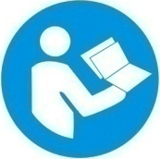  User  Manual | 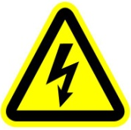  Electrical shock |   Goggles |   Protective Gloves | 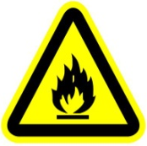  Flames | 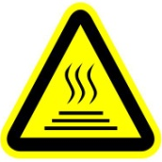  High Temperature

 | ● When unpacking, check if there is transportation damage before using a projector. Should there be any damage caused by transportation, consult your dealer and do not use it.  ● The manufacturer is not responsible for any loss caused by the user not following the manual or changing a projector as he/she likes.  ● Please be noted that the damage caused by changing a projector at will is not warranted.  ● Do not hesitate to contact the dealer or the manufacturer if any questions or advice.  ● If a lamp is damaged or deforms because of heat, it should be replaced.( It applies only to traditional lamps)
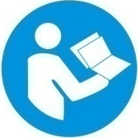 | ● The projector is for indoor and outdoor use, IP66.  ● It can be used in humid and dusty areas. And it can contact water and other non-corrosive liquids.  ●The projector should be kept away from high temperature, fire, electrical surge, vibration and strong light while being operated  ●The projector is only intended for installation, operation and maintenance by qualified personnel. And the operation must strictly follow the procedures in the manual  ●No repairable parts in the projector and do not open covers for maintenance by yourself.  .  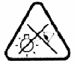
● Don’t look straightly into the light sources especially for epileptics, otherwise eyes will be burned.
● Do not connect a projector to any type of dimmer pack.
● If the lamp, lens and screen protective cover of the a projector have obvious damage, i.e., to the extent that it hurts the performance like cracking or deformation. Please stop using it and replace them with the original parts, otherwise its performance will be compromised.
● For the installation location of a projector, it shouldn’t be seen in the distance of less than 4 meters for a long time.

 | ● Before operation, please confirm that all covers (housing) are on and screws tightened. It’s forbidden to use a projector while covers (housing)are off .  ● Keep the lamp clean and do not touch it with bare hands.  ● While operating it, wear protective items like eye goggles , gloves and etc..
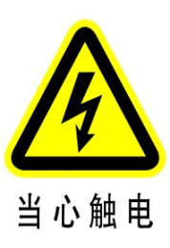 | ● Any electrical connection must be carried out by a qualified person .  ● Before installation, please confirm the voltage supplied matches what is required for a projector.  ● Each projector must be properly earthed and installed as per related electrical standards.  ● Do not use power cord with its insulator damaged and connect the power cord with other cables.  ● If a projector is not used or under cleaning,, please hold the plug and unplug it. Do not unplug it forcefully or by pulling the power cable.  ● All power cords must conform to related safety and regulations.  ● If a projector is not water and dust proof, while being operated it should not be under rains or in humidity to avoid short circuit.  ● Do not switch on and off a projector constantly in very short intervals, otherwise the light source’s and other electrical parts’ life will be shortened .
 | ● There are safety cord holes at the bottom of the base of a projector. In view of safety, please run the safety cord supplied through the safety cord holes for safety support.  ● Before any installation, maintenance and cleaning work, please ensure a projector is disconnected from power mains.
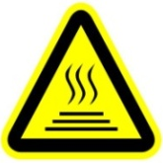 | ● While running normally under normal ambient temperature, the temperature of the external surface of the metal housing of a projector including that of the heat sink may reach 75℃ at maximum.  ● While the lamp is stricken for the first time, there will be smoke and strange smell. It’s normal and does not mean a projector has some defects.  ● While it running, don’t touch the metal housing to avoid being burned!
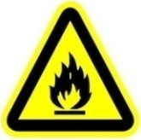 | ● Do not mount a projector directly on inflammable surface.  ● Do not project the beam straightly on combustible items and the minimum distance between a projector  and illuminated items is 18m.  ● A projector should be installed with good ventilation and the minimum distance between a projector and a wall is 50cm. At the same time, please ensure the fans and air inlets and outlets are workable.  ● Do not let the front lens under sunlight or other strong light sources at any angle, otherwise the danger of fire can be caused by the focused beam by the lens inside a projector.


● The product meets The General Technical Requirements and Standards for Recycle and Use Of Expired Appliance and Electronic Products.
● When the product meets disposal standards and needs to be disposed, a client needs to dispose and recycle it.

2. INSTRUCTIONS
●CLEANING AND MAINTENANCE
Under normal running, the protective units of a projector should be inspected regularly like power fuse. If it is burned, please install a new one and ensure it is the same rating as the burned one. For a projector with an over-temperature protective unit, please inspect cooling units regularly like cooling fans, heat sink and other cooling parts. Please check if the fans run normally or fans and air inlets are blocked by dust. To keep air inlets /outlets clean, cooling fans should be cleaned every 15days.

For projectors with lens, reflectors and coated filters, the accumulation of oil, smoke and dust on them will compromise the light output. Cleaning a projector is very necessary to ensure a reliable use. Internal and external lens, flat glass, reflector and coated filters need to be cleaned periodically to optimize light output.

Cleaning frequency is to be decided by operations and its environment. Use soft cloth and normal detergent for glass for cleaning work. It’s advised external optical system be cleaned every 20days and internal optical systems every 30/60days. For a projector with high IP rating, if no damage inside, it is advised to clean the surfaces of its housing in principle. Keep lens clean and do not touch optical parts with bare hands.

SPECIAL NOTE:
It’s normal phenomena that there will be mild water mist on the lens while the waterproof product is in use.

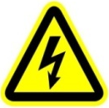 | ● Before any maintenance and cleaning, please ensure a project is off the power.  ● Only a qualified person is allowed to do maintenance.
 | ● To avoid sunlight or other light penetrating into the head via the front lens, resulting in high temperature internally causing damages to a projector. Before power-off, please use Tilt channel to move the head and make the head facing downward.  ● Do not use alcohol or other organic solvent to clean the housing to avoid damage.  ● Do not use any solvent with chemical elements to clean coated filters.

●LUBRICATION
To ensure smooth movement of gobos and zoom and focus lens, it’s advised rotators’ bearings and 2 sliding bars for zoom and focus lens be lubricated every 2 months. High quality and high temperature lubricant/grease is advised..

●TROUBLESHOOTING
PROBLEM | ACTION
A projector doesn’t switch on | - Check the fuse on the power socket.  - Check the lamp.
The lamp is on but a projector doesn’t respond to the controller | - Make sure that the fixture’s start address is right  - Replace or repair the XLR signal cable.
A projector functions intermittently | - Make sure the fan is working well or fans and their shields are not blocked
Beam appears dim, Low in brightness | - Make sure the lamp is within its lifespan  - Remove dust or grease from the lenses.
The project image appears to have a halo | - Carefully clean the lamp, optical lenses and other components.
Heavily Defective Beam | - Check if lens are in good condition(not cracked)  - Clean dust or grease on the lens.

- INSTALLATION
● RIGGING
Before moving a projector, Please lock Pan and Tilt. Before its operation, please unlock them. It’s forbidden to run a projector with power while it is locked.
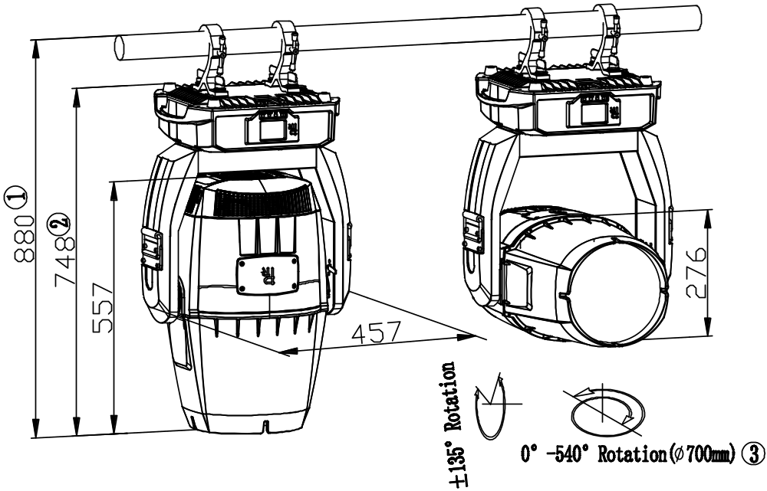
Remarks:
- The distance between the top of the mounting bar and the top of the head;
- The Distance between the top of the feet and the top the head;
- The head’s rotating diameter( the minimum distance between 2 neighboring projectors on the truss)

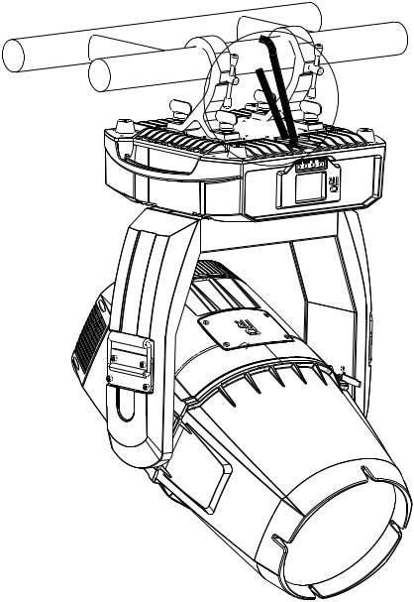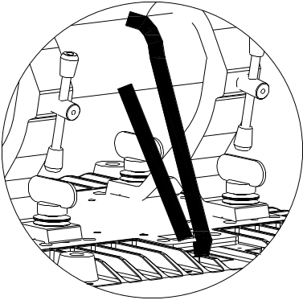
Warning!
For safety, please run the safety cord through its hole.
Safety cord
Clamp

Take 2 clamps and the safety cord out from the package and mount 2 clamps on the underside of fixture with 2 retainers attached to each clamp. Hang the fixture on the structure and fasten the screws attached to each clamp. (See the WARNING on the underside of the base as shown above) To pass the SAFETY CORD through the HOLES for safety! Always ensure that the projector is firmly anchored to avoid vibration and slipping whilst functioning. Always ensure that the structure that you are going to mount the projector to is secure and strong enough to support the weight of a XR 1000 Framing.

WARNING:
●The projector MUST be lifted or carried by the HANDLES instead of clamps.
●.For safety the safety cord should afford 10 times the Projector’s weight.

● POWER CONNECTION
Connect the power cord as follows:
L (live) =brown
E (earth) =yellow/green
N (neutral) =blue

Before power connection, please ensure the power supplied must match what the nameplate says. It is recommended that each projector be connected with power separately so that they may be individually switched on and off.

●The earth wire(yellow/green) must be connected to the ground. And electrical connection must be in accordance with the standards concerned.
●If any questions about the electrical installation, do not continue but consult a qualified electrician.

●DMX CONTROL CONNECTION:

Connection between controller and projector and between one projector and another must be made with a twin-screened cable, with each wire having at least a 0.5mm in diameter. Connection to and from the projector is via cannon 5 pin (which are included with the projector) or 5 pin XLR plugs and sockets. The XLR's are connected as shown in the figure above.

Note: care should be taken to ensure that none of the pins touch the metallic body of the plug or each other. XLR plugs and sockets mustn’t be connected in any way other than mentioned in the above figure. The XR330BWS accepts digital control signals in protocol DMX512 (1990).

Connect the controller’s DMX output to the first fixture’s DMX input, and connect the first fixture’s DMX output to the second fixture’s DMX input and connect the rest fixtures in the same way. Eventually connect the last fixture’s DMX output to a DMX terminator as shown in the figure below.

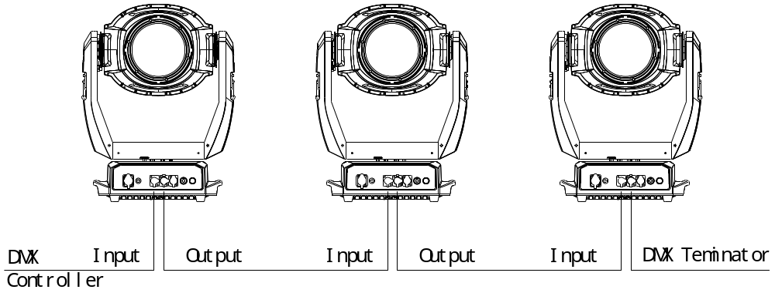

●DMX TERMINATOR
In the Controller mode, at the last fixture in the chain, the DMX output has to be connected with a DMX terminator. This prevents electrical noise from disturbing and corrupting the DMX control signals.
The DMX terminator is simply an XLR connector with a 120Ω (ohm) resistor connected across pins 2 and 3, which is then plugged into the output socket on the last projector in the chain. The connections are illustrated below.

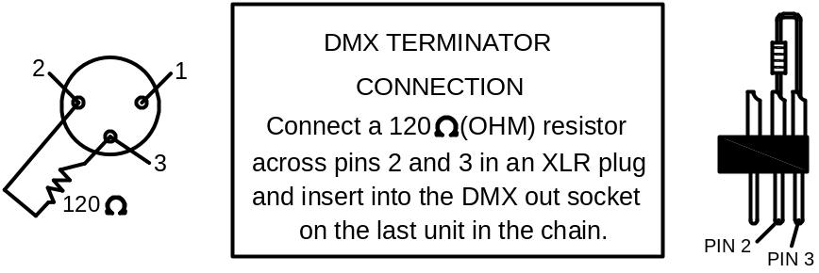

4. SETUP AND CONFIGURATION
●FRONT PANEL OPERATION
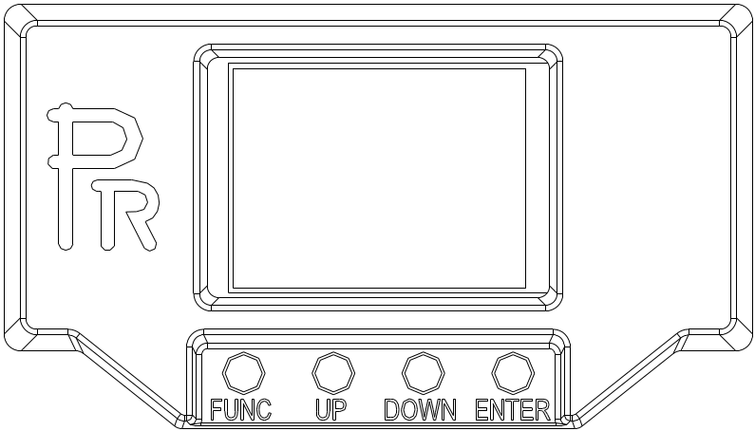
To browse through or change the projector ’s settings, press ENTER key for more than 3s(press ENTER key after power on) to unlock the screen , then press UP/DOWN key to enter the projector ’s function menus. Each main menu has its sub-menus. And each menu stands for special function. For the details, please see the following 6th point ”Operation Menu”.:

- At the page to set the fixture’s functions, press UP or DOWN key to select the functions desired.

- While menu operations, the FUNC key to escape, and ENTER key is used to confirm. Press ENTER key to save the changes or enter into the sub menus. Press UP or DOWN key to change the numbers(minus or plus).

Press FUNC key to go to the uppler menu. If no key is pushed, the system will go back to initial status automatically.
● DMX START ADDRESS

Each projector must be given a DMX start address so that the correct projector responds to the correct control signals. This DMX start address is the channel number from which the projector starts to “listen” to the digital control information being sent out from the controller. The projector has 3DMX modes. There are standard mode ,short mode and extended mode. For example standard mode has 25 channels, so set the No. 1 projector’s address 001, No. 2 projector’s address 026, No. 3 projector’s address 051,No. 4 projector’s address 076, and so on.

Switch on the Projector . Press ENTER key more than 3 seconds to unlock panel, then press UP or DOWN key to enter into the fixture’s operation menus.
Select DMX Address icon and press ENTER key on the display and select DMX address at the 2nd level menu for the address setting.
Press UP or DOWN key for the DMX address desired.
Press ENTER key to confirm.
Press the FUNC key to go back to the upper level menu.
.
●DMX WIRELESS CONTROL(Only for fixtures with wireless control)

The projector has wireless control function with wireless receiver module and antenna for remote control.
The setup of it is below:
1. Press ENTER for more than 3s to unlock the control panel, then press UP or DOWN key to enter into the operation menu and select “Config Settings”.
2. Select “Wireless Only” from the menu of “Signal Select”.
Only after the projector is linked with a transmitter, can it receive wireless signal sent by the transmitter. If unlinking it, Press “Enter” for the menu of Un-link Wireless under the upper level menu of Config Settigns , then the fixture is unlinked with the wireless transmitter.

●STAND-ALONE MODE
Operate the projector without connecting with a controller, enable the master mode through the operation panel, the projector will run in Stand-Alone mode automatically.
DMX address can be set at any number within 512.
●MASTER/SLAVE MODE
Many projectors can run synchronously in the Master/Slave mode by linking them with each other. First,
connect the first fixture’s DMX output to the second fixture’s DMX input using XLR-XLR control cable and then connect the second fixture’s DMX output to the third fixture’s DMX input, and so on until all projector are connected in this way. Eventually connect the last fixture’s DMX output to a DMX terminator. Set 1st projector as the master and others are Slaves.

Start Addresses of all Slaves are 001; Operation mode of the Master can be set any mode for a Master’ and Slaves’ operation mode can be set accordingly.

After Powered on, the group will run in Master/Slave Mode

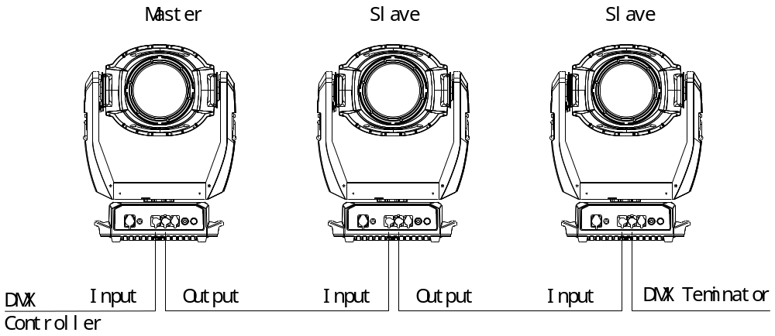

5.OPERATION MENU

1st LEVEL | 2nd LEVEL | 3rd LEVEL | 4th LEVEL |  | 5th LEVEL
  Address | DMX Address | 1-492(Short Mode)  1-488(Standard Mode)  1-485(Extend Mode)
 | IP Address | Default IP Address | 2.X.X.X /10.X.X.X
 | IP Address | Custom IP Address | X.X.X.X
 | SubNet Mask | X.X.X.X
 | ArtNet  ArtNet Universe | 0-255
 | sACN universe | 1-63999
Reset   | Total Reset | Really Reset?  Confirm or Cancel
 | Pan&Tilt Reset | Really Reset?  Confirm or Cancel
 | Color System Reset | Really Reset?  Confirm or Cancel
 | Dimmer/Shutter Reset | Really Reset?  Confirm or Cancel
 | Gobo Wheel Reset | Really Reset?  Confirm or Cancel
 | Fo. Pr. Reset | Really Reset?  Confirm or Cancel
Config Settings   | DMX Channel Mode | Short Mode 21CH
 | DMX Channel Mode | Standard Mode 25CH
 | DMX Channel Mode | Extended Mode 28CH
 | DMX Channel Mode | View Selected Mode | Ch.01 Strobe  Ch.02 Dimmer  …  Ch. XX control function
 | Signal Select  (Only for fixtures with wireless control) | XLR Only
 | Signal Select  (Only for fixtures with wireless control) | XLR First
 | Signal Select  (Only for fixtures with wireless control) | Wireless Only
 | Signal Select  (Only for fixtures with wireless control) | Wireless First
 | Signal Select  (Only for fixtures with wireless control) | Wireless In/XLR Out
 | Signal Select  (Only for fixtures with wireless control) | Artnet Only
 | Signal Select  (Only for fixtures with wireless control) | Artnet In/XLR Out
 | Signal Select  (Only for fixtures with wireless control) | sACN only
 | Signal Select  (Only for fixtures with wireless control) | sACN/XLR
 | Loss of DMX | Normal time out
 | Loss of DMX | Hold Last Value
 | Display Config | Display Mode | Off After Delay
 | Display Config | Display Mode | On Always
 | Display Config | Display Invert | Invert OFF
 | Display Config | Display Invert | Invert ON
 | Display Config | Display Invert | Invert Auto
 | Display Config | Language Setting | English\Chinese
 | Temperature Unit | Celsius Degree
 | Temperature Unit | Fahrenheit Degree
 | Un-Link Wireless  (Only for fixtures with wireless control) | Really Un-Link?  Confirm or Cancel
 | Factory Defaults | Restore Defaults?  Confirm or Cancel
Option Settings   | Pan/Tilt Settings | Pan DMX Invert | OFF/ ON
 | Pan/Tilt Settings | Tilt DMX Invert | OFF/ ON
 | Pan/Tilt Settings | Pan Tilt Swap | OFF/ ON
 | Pan/Tilt Settings | XY Feedback | OFF/ ON
 | Pan/Tilt Settings | Pan/Tilt mode | Speed/Time |  | Note: "Speed Mode" means Pan and Tilt will move from Point A to Point B at their respective maximum speeds."Time Mode" means both Pan and Tilt will arrive at designated point at the same time. It's advised Time Mode be used if the projector runs circles or in oblique lines.
 | Other Invert Settings | CMY Invert | OFF/ ON
 | Dimmer Settings | Dimmer Speed | Fast/Medium/Slow Speed
Information   | View DMX Values | Channel Value  Strobe XXX  Dimmer XXX  CMY Macro XXX  Cyan XXX  Yellow XXX  Magenta XXX  Color Wheel XXX  FixedGoboWheelXXX  Rota. GoboWheelXXX  Gobo Rota. XXX  Prism 1 XXX  Prism 1 Rotation XXX  Prism 2 XXX  Prism 2 Rotation XXX  Focus XXX  Pan XXX  Tilt XXX  ControlFunction XXX
 | Lamp Hours | Lamp Hous=XXX H  Reset Lamp Hours
 | Total Hours | Total Hous ××××H
 | Temperature | Display Board=×××C  Pan board=×××C  Tilt board=×××C  Motor driver board1=×××C  Motor driver board2=×××C  Light source driver board =×××C  Light source==×××C  Head Sensor=×××C
 | Software Version | PCB System bootloader  Display Board xxx xxx  Pan board xxx xxx  Tilt board xxx xxx  Motordriverboard1xxx xxx  Motordriverboard2xxx xxx Lightsourcedriverboard xxx
 | Electronic SN | XXXXXX
 | RDM Device Label | ANSI E1.20 RDM
 | Fan Status | Fan Speed Status  Base fan xxx on/off  Gobo fan xxx on/off  CMY fan xxx on/off  Lens fan xxx on/off  Chamberfan xxx on/off  Head fan xxx on/off  Lightsourcefanxxx on/off
 | Lamp Fan Error
  Service | Manual Effect Control | Channel Value  Strobe XXX  Dimmer XXX  CMY Macro XXX  Cyan XXX  Yellow XXX  Magenta XXX  Color Wheel XXX  FixedGobo Wheel XXX  Rota. GoboWheelXXX  Gobo Rota. XXX  Prism1 XXX  Prism 1 Rotation XXX  Prism 2 XXX  Prism 2 Rotation XXX  Focus XXX  Pan XXX  Tilt XXX
 | Factory Mode | XXX
Operation Mode   | DMX Mode | Change Operation Mode?  Confirm or Cancel
 | Master Mode | Preset Memory | Change Operation Mode?  Confirm or Cancel
 | Master Mode | User Memory 1 | Change Operation Mode?  Confirm or Cancel
 | Master Mode | User Memory 2 | Change Operation Mode?  Confirm or Cancel
 | Stand-Alone Mode | Preset Memory | Change Operation Mode?  Confirm or Cancel
 | Stand-Alone Mode | User Memory 1 | Change Operation Mode?  Confirm or Cancel
 | Stand-Alone Mode | User Memory 2 | Change Operation Mode?  Confirm or Cancel
 | Static Scene | Change Operation Mode?  Confirm or Cancel
User Memories   | Edit User Memory | Edit User Memory 1  /  Edit User Memory 2 | （1~200Scenes）  Scene XX  （1~200 Scenes） | Paste?  Confirm or Cancel | Strobe XXX  Dimmer XXX  CMYMacro XXX  Cyan XXX  Yellow XXX  Magenta XXX  ColorWheel XXX  FixedGoboWheelXX  Rota.GoboWheelXX  GoboRota. XXX  Prism1 XXX  Prism1Rotation XXX  Prism2 XXX  Prism2Rotation XXX  Focus XXX  Pan XXX  Tilt XXX  Hold time XXX  DelayTime XXX  Delaytimeunit ms/s/m  LinktoStep XXX
 | Edit User Memory | Edit Static Scene | Paste?  Confirm or Cancel |  | Strobe XXX  Dimmer XXX  CMYMacro XXX  Cyan XXX  Yellow XXX  Magenta XXX ColorWheel XXX  FixedGoboWheelXX  Rota.GoboWheelXX  GoboRota. XXX  prism1 XXX  Prism1Rotation XXX  Prism2 XXX  Prism2Rotation XXX  Focus XXX  Pan XXX  Tilt XXX
 | Init User Memory | Reset User Memory 1 | Reset User Memory?  Confirm or Cancel
 | Init User Memory | Reset User Memory 2 | Reset User Memory?  Confirm or Cancel
 | Init User Memory | Reset Static Scene | Reset Static Scene?  Confirm or Cancel

6. DMX PROTOCOL
Short  mode | Standard  Mode S | Extended  Mode E | FUNCTION | DMX | DESCRIPTION
1 | 1 | 1 | Strobe | 000 | Close
 |  |  |  | 001-127 | Pulse Strobe speed from slow to fast
 |  |  |  | 128-255 | Strobe from slow to fast
2 | 2 | 2 | Dimmer | 000-255 | Linear dimming（0-100%）
 | 3 | 3 | Dimmer Fine | 000-255 | Dimmer in 16 bit
3 | 4 | 4 | CYM Macro | 000-016 | White
 |  |  |  | 017-035 | Yellow+ Magenta=Red
 |  |  |  | 036-054 | Yellow
 |  |  |  | 055-073 | Yellow +Cyan=Green
 |  |  |  | 074-092 | Cyan
 |  |  |  | 093-111 | Cyan + Magenta= purple
 |  |  |  | 112-128 | Magenta
 |  |  |  | 129-255 | CYM color mixing from slow to fast
4 | 5 | 5 | Cyan | 000-255 | Cyan (linear 0~100%)
 |  | 6 | Cyan Fine | 000-255 | Cyan in 16 Bit
5 | 6 | 7 | Yellow | 000-255 | Yellow (linear 0~100%)
 |  | 8 | Yellow Fine | 000-255 | Yellow in 16 Bit
6 | 7 | 9 | Magenta | 000-255 | Magenta (linear 0~100%)
 |  | 10 | Magenta Fine | 000-255 | Magenta in 16 Bit
7 | 8 | 11 | Color Wheel | 000-063 | Indexing(0-360degrees)
 |  |  |  | 064-067 | Open
 |  |  |  | 068-070 | Color1
 |  |  |  | 071-073 | Color2
 |  |  |  | 074-076 | Color3
 |  |  |  | 077-079 | Color4
 |  |  |  | 080-082 | Color5
 |  |  |  | 083-085 | Color6
 |  |  |  | 086-088 | Color7
 |  |  |  | 089-091 | Color8
 |  |  |  | 092-094 | Color9
 |  |  |  | 095-097 | Color10
 |  |  |  | 098-100 | Color11
 |  |  |  | 101-103 | Color12
 |  |  |  | 104-106 | Color13
 |  |  |  | 107-109 | Color14
 |  |  |  | 110-112 | Color15
 |  |  |  | 113-115 | Color16
 |  |  |  | 116-118 | Color17
 |  |  |  | 119-121 | Color18
 |  |  |  | 122-124 | Color19
 |  |  |  | 125-127 | Open
 |  |  |  | 128-191 | Rotation ,Clockwise from slow to fast
 |  |  |  | 192-255 | Rotation, Anti-clockwise from fast to slow
 | 9 | 12 | Color Wheel Fine | 0000-255 | Color Wheel in 16 Bit
8 | 10 | 13 | Fixed Gobo Wheel | 0-11 | Open
 |  |  |  | 12-15 | Gobo1
 |  |  |  | 16-19 | Gobo2
 |  |  |  | 20-23 | Gobo3
 |  |  |  | 24-27 | Gobo4
 |  |  |  | 28-31 | Gobo5
 |  |  |  | 32-35 | Gobo6
 |  |  |  | 36-39 | Gobo7
 |  |  |  | 40-43 | Gobo8
 |  |  |  | 44-47 | Gobo9
 |  |  |  | 48-51 | Gobo10
 |  |  |  | 52-55 | Gobo11
 |  |  |  | 56-59 | Gobo12
 |  |  |  | 60-63 | Gobo13
 |  |  |  | 64-67 | Gobo14
 |  |  |  | 68-71 | Gobo15
 |  |  |  | 72-75 | Gobo16
 |  |  |  | 76-79 | Gobo17
 |  |  |  | 80-83 | Gobo18
 |  |  |  | 84-87 | Gobo19
 |  |  |  | 88-91 | Gobo20
 |  |  |  | 92-95 | Gobo21
 |  |  |  | 96-99 | Gobo22
 |  |  |  | 100-103 | Gobo23
 |  |  |  | 104-107 | Gobo24
 |  |  |  | 108-111 | Gobo25
 |  |  |  | 112-115 | Gobo26
 |  |  |  | 116-119 | Gobo27
 |  |  |  | 120-123 | Gobo28
 |  |  |  | 124-127 | Gobo29
 |  |  |  | 128-149 | Clockwise rotation from slow to fast
 |  |  |  | 150-171 | Anti Clockwise rotation from slow to fast
 |  |  |  | 172-174 | Shake effect 1 from slow to fast
 |  |  |  | 175-177 | Shake effect 2 from slow to fast
 |  |  |  | 178-180 | Shake effect 3 from slow to fast
 |  |  |  | 181-183 | Shake effect 4 from slow to fast
 |  |  |  | 184-186 | Shake effect 5 from slow to fast
 |  |  |  | 187-189 | Shake effect 6 from slow to fast
 |  |  |  | 190-192 | Shake effect 7 from slow to fast
 |  |  |  | 193-195 | Shake effect 8 from slow to fast
 |  |  |  | 196-198 | Shake effect 9 from slow to fast
 |  |  |  | 199-201 | Shake effect 10 from slow to fast
 |  |  |  | 202-204 | Shake effect 11 from slow to fast
 |  |  |  | 205-207 | Shake effect 12 from slow to fast
 |  |  |  | 208-210 | Shake effect 3 from slow to fast
 |  |  |  | 211-213 | Shake effect14 from slow to fast
 |  |  |  | 214-216 | Shake effect 15 from slow to fast
 |  |  |  | 217-219 | Shake effect 16 from slow to fast
 |  |  |  | 220-222 | Shake effect 17 from slow to fast
 |  |  |  | 223-225 | Shake effect 18 from slow to fast
 |  |  |  | 226-228 | Shake effect19 from slow to fast
 |  |  |  | 229-231 | Shake effect20 from slow to fast
 |  |  |  | 232-234 | Shake effect21 from slow to fast
 |  |  |  | 235-237 | Shake effect 22 from slow to fast
 |  |  |  | 238-240 | Shake effect 23 from slow to fast
 |  |  |  | 241-243 | Shake effect24 from slow to fast
 |  |  |  | 244-246 | Shake effect25 from slow to fast
 |  |  |  | 247-249 | Shake effect 26 from slow to fast
 |  |  |  | 250-252 | Shake effect27 from slow to fast
 |  |  |  | 253-255 | Shake effect 28 from slow to fast
9 | 11 | 14 | Rotating Gobo Wheel | 00-7 | Open
 |  |  |  | 8-17 | Gobo1
 |  |  |  | 18-27 | Gobo 2
 |  |  |  | 28-37 | Gobo 3
 |  |  |  | 38-47 | Gobo 4
 |  |  |  | 48-57 | Gobo 5
 |  |  |  | 58-67 | Gobo 6
 |  |  |  | 68-77 | Gobo 7
 |  |  |  | 78-87 | Gobo8
 |  |  |  | 88-97 | Gobo9
 |  |  |  | 98-107 | Gobo 10
 |  |  |  | 108-117 | Gobo 11
 |  |  |  | 118-127 | Gobo 12
 |  |  |  | 128-143 | Rotation （clockwise From slow to Fast）
 |  |  |  | 144-159 | Reverse Rotation（anti-clockwise From slow to Fast）
 |  |  |  | 160-167 | Shake of Gobo 1 from slow to fast
 |  |  |  | 168-175 | Shake of Gobo 2 from slow to fast
 |  |  |  | 176-183 | Shake of Gobo 3 from slow to fast
 |  |  |  | 184-191 | Shake of Gobo 4 from slow to fast
 |  |  |  | 192-199 | Shake of Gobo 5 from slow to fast
 |  |  |  | 200-207 | Shake of Gobo 6 from slow to fast
 |  |  |  | 208-215 | Shake of Gobo 7 from slow to fast
 |  |  |  | 216-223 | Shake of Gobo 8 from slow to fast
 |  |  |  | 224-231 | Shake of Gobo 9 from slow to fast
 |  |  |  | 232-239 | Shake of Gobo10 from slow to fast
 |  |  |  | 240-247 | Shake of Gobo 11 from slow to fast
 |  |  |  | 248-255 | Shake of Gobo12 from slow to fast
10 | 12 | 15 | Gobo Rotation | 0-128 | Gobo Indexing(0~540degrees)
 |  |  |  | 129-188 | Rotation （Clockwise From slow to Fast）
 |  |  |  | 189-195 | Stop
 |  |  |  | 196-255 | Rotation （Anti-Clockwise From slow to Fast）
 | 13 | 16 | Gobo Rotation Fine | 0-255 | Gobo Rotation in 16 Bit
11 | 14 | 17 | Prism 1 | 000-016 | Open
 |  |  |  | 017-127 | Prism1
 |  |  |  | 128-255 | Prism2
12 | 15 | 18 | Prism1 Rotation | 000-127 | Prism Indexing
 |  |  |  | 128 | Stop
 |  |  |  | 129-191 | Rotation(Clockwise from slow to fast)
 |  |  |  | 192 | Stop
 |  |  |  | 193-255 | Rotation(Anti- Clockwise from slow to fast)
13 | 16 | 19 | Prism 2 | 000-016 | White
 |  |  |  | 017-127 | Prism3
 |  |  |  | 128-255 | Frost in
14 | 17 | 20 | Prism2 Rotation | 000-127 | Prism2 Indexing
 |  |  |  | 128 | Stop
 |  |  |  | 129-191 | Rotation(Clockwise from slow to fast)
 |  |  |  | 192 | Stop
 |  |  |  | 193-255 | Rotation(Anti- Clockwise from slow to fast)
15 | 18 | 21 | Focus | 000-255 | Linear focus
 | 19 | 22 | Focus Fine | 000-255 | Focus in 16 bit precision
16 | 20 | 23 | Pan | 000-255 | Pan(0°~540°)
17 | 21 | 24 | Pan Fine | 000-255 | Pan in 16 bit
18 | 22 | 25 | Tilt | 000-255 | Tilt(0°~270°)
19 | 23 | 26 | Tilt Fine | 000-255 | Tilt in 16 bit
20 | 24 | 27 | Pan & Tilt Speeds | 000-255 | Pan & Tilt Speed from Fast to Slow
21 | 25 | 28 | Control | 000-019 | Reserved
 |  |  |  | Keep in the DMX range for more than 5S to activate the following functions. If power-off, the following are invalid.
 |  |  |  | 020-024 | Graphic Display On
 |  |  |  | 025-029 | Graphic Display Off
 |  |  |  | 030-052 | Reserved
 |  |  |  | 053-054 | Diming speed fast
 |  |  |  | 055-056 | Diming speed Medium
 |  |  |  | 057-058 | Diming speed slow
 |  |  |  | 059-089 | Reserved
 |  |  |  | 090-094 | Pan & Tilt Speed Mode
 |  |  |  | 095-099 | Pan & Tilt Time Mode
 |  |  |  | 100-139 | Reserved
 |  |  |  | 140-149 | Pan & Tilt Reset
 |  |  |  | 150-159 | Color System Reset
 |  |  |  | 160-169 | Gobo Wheel Reset
 |  |  |  | 170-179 | Reserved
 |  |  |  | 180-189 | Focus/Prism Reset
 |  |  |  | 190-199 | Reserved
 |  |  |  | 200-209 | Total Reset
 |  |  |  | 210-255 | Reserved

Remarks:

- Fan error can cause lamp-off.

- Note: "Speed Mode" means Pan and Tilt will move from Point A to Point B at their respective maximum speeds."Time Mode" means both Pan and Tilt will arrive at designated point at the same time. It's advised Time Mode be used if the projector runs circles or in oblique lines.

7. ERROR MESSAGES
The system can detect some errors during the reset, if  displayed, touch to view the error.
The error messages are as follows:
Name | Type | Correction
Pan | Timeout/magnet Sensor/Encoder | Check if wiring, positioning parts and motors are normal
Tilt | Timeout/magnet Sensor/Encoder | Check if wiring, positioning parts and motors are normal
Cyan | Timeout | Check if wiring, positioning parts and motors are normal
Yellow | Timeout | Check if wiring, positioning parts and motors are normal
Magenta | Timeout | Check if wiring, positioning parts and motors are normal
Color Wheel | Timeout | Check if wiring, positioning parts and motors are normal
Fixed gobo wheel | Timeout | Check if wiring, positioning parts and motors are normal
Rotating gobo wheel | Timeout | Check if wiring, positioning parts and motors are normal
Gobo rotation | Timeout | Check if wiring, positioning parts and motors are normal
Dimmer | Timeout | Check if wiring, positioning parts and motors are normal
Prism | Timeout | Check if wiring, positioning parts and motors are normal
Prism Rotation | Timeout | Check if wiring, positioning parts and motors are normal
Focus | Timeout | Check if wiring, positioning parts and motors are normal
Fan | Error | Check if fan and its wiring are normal
Pan Board | Error | Check signal wire
Tilt Board | Error | Check signal wire
Motor Driver Board1 | Error | Check signal wire
Motor Driver Board2 | Error | Check signal wire
Light source driver board
Acceleration Sensor | Error | Check signal wire
Lamp on | Timeout | Check if he lamp is damaged
Lamp Life | Timeout Warning
Lamp Off[Fan Error] | Error | Check if all fans are normal
Time IC | Error

8. TECHNICAL DATA
Electric parameters
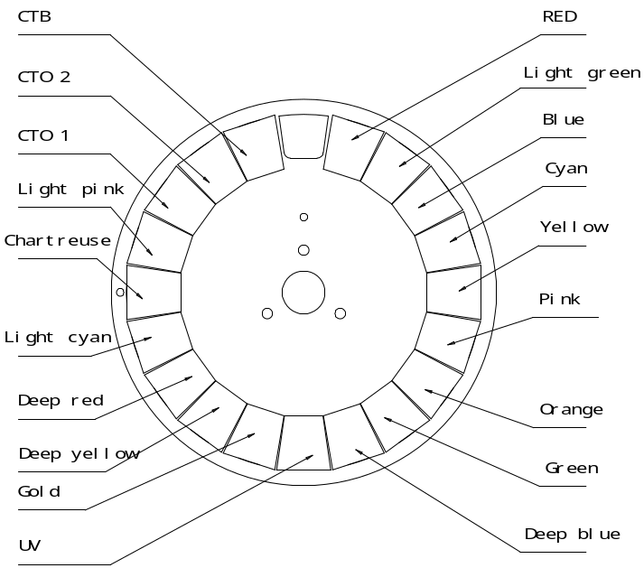
Input voltage: 100V~240V AC，50/60Hz
Power consumption: 420W @ 220V
Rated current: 2.0A @ 220V
Power factor: PF>0.9
Light sources
Light sources | 260W laser module
Colortemperature | 9000K
Rated life | 12000hrs
Colors
1 color wheel: 19 colors + open
Macros and bi-directional rainbow effects with variable speeds
a linear CYM color mixing system
Gobo wheels
1 fixed gobo wheel: 30 gobos
Shakable at variable speeds and bi-directional rotation at variable speeds

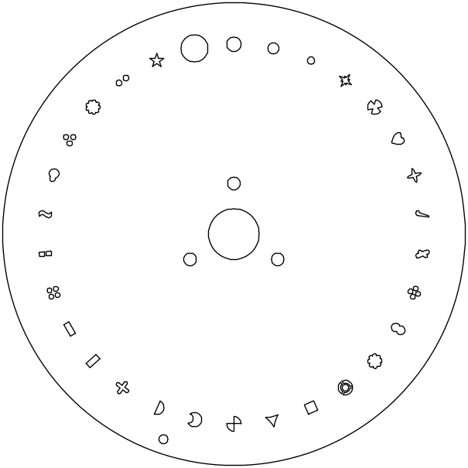
ROTATING GOBO WHEEL
1Rotating gobo wheel: 12 gobos+ Open
Shaking and bi-directional wheel scrolling at variable speeds
Gobo changeable. Gobo outer size: Ф10mm, image sizeФ6mm
Gobo 1 | Gobo 2 | Gobo 3 | Gobo 4 | Gobo 5 | Gobo 6 | Gobo 7
 |  |  |  |  |  | 
Gobo 8 | Gobo 9 | Gobo 10 | Gobo 11 | Gobo 12
 |  |  |  | 

Prism/frost：
2 prism wheels: 1 wheel (an 8-facet circular prism+ a 4-facet linear prism )+1 wheel (a 16-facet circular prism + a frost filter), prisms overlapped. Other prism options available.
Focus
DMX linear focus
Strobe/dimmer
Double flag strobe，0.3-25 F.P.S. / linear dimmer

Movements
Pan (0°-540°)，Tilt( 0°-270°) with auto positioning correction function

Beam angle
Beam angle：0.8°
Control
International standard DMX 512 signal,5-pin XLR connectors
Short Mode21 channels，standard Mode 25channels,extended mode 28channels
Self test mode
Other functions
Pan and Tilt speeds adjustable
Lamp hours and fixture hours displayed
Modular construction easy for maintenance
Wireless receiver
Optional wireless transmitter
Art-Net function

Housing and ingress protection
Cast aluminum and high temperature and UV resistant ABS with IP66
Weight
Net weight：39 Kgs
Ambient temperature
-20 °C ~ 45 °C
Note：If a fixture runs with the ambient temperature below 0 Celsius, it should be heated for some time(less than 20 minutes based on actual conditions) before turning on the laser module.

Sizes （unit：mm）

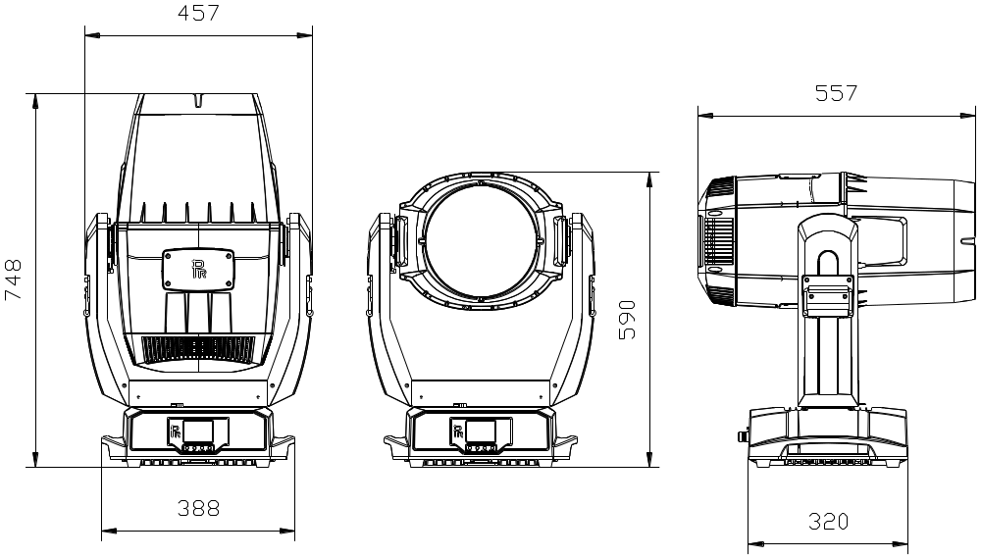

Light output

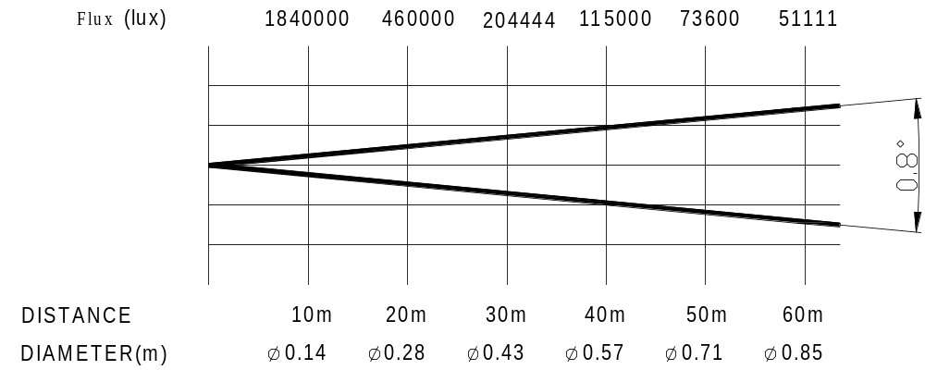

9. CIRCUIT DIAGRAM
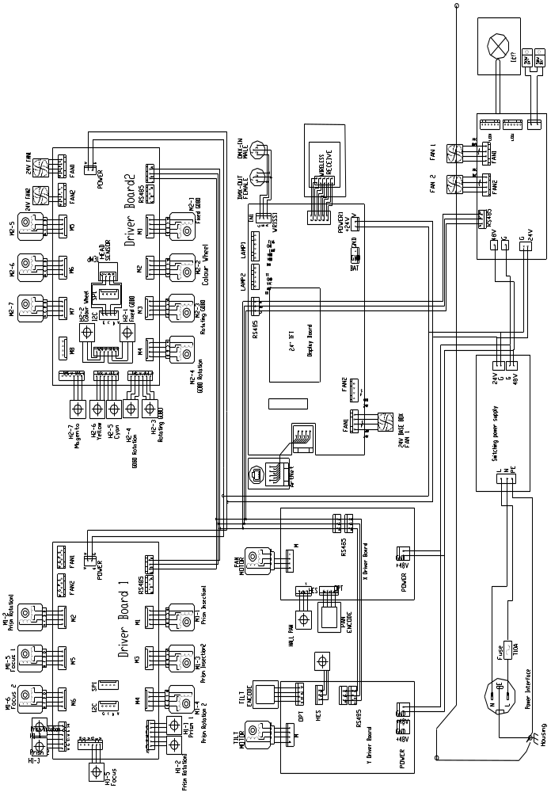

10. COMPONENT ORDER CODES

NO | NAME | CODE NUMBER | QTY
SWITCHING POWER SUPPLY | 192010237 | 1
LIGHT SOURCE | 150020339 | 1
HEAD FAN | 030060116 | 1
CHAMBER FAN | 030060117 | 1
LENS FAN | 030060106 | 1
LIGHT SOURCE FAN | 030060121 | 1
BASE FAN | 030060075 | 1
PAN MOTOR | 030040246B | 1
TILT MOTOR | 030040278B | 1
FOCUS MOTOR | 030040243A | 2
FIXED GOBO MOTOR | 030040221C | 1
COLOR WHEEL MOTOR | 030040221C | 1
PRISM IN/OUT MOTOR | 030040221C | 2
PRISM ROTATION MOTOR | 030040254 | 2

PR LIGHTING LTD.

1582 Xingye Avenue, Nancun Panyu
Guangzhou, 511442 China
TEL: +86-20-3995 2888

PR lighting will try its best to offer accurate and overall information about a product’s technical data. Any changes won’t be notified if necessary. Patented Products. Counterfeiting Will be Prosecuted!

P/N: 320021446
Old Version: 20220927
New Version: 20221221

