

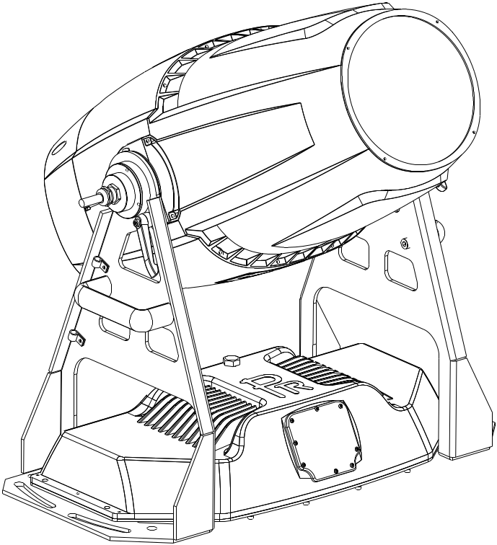

TANGO 1800 FRAMING

PR-6617

The user manual contains important information about the safe installation and use of a projector. Please read and follow these instructions carefully and keep the manual in a safe place for future reference.

PR LIGHTING LTD.
http://www.pr-lighting.com

INDEX

1. | SAFETY AND WARNINGS…………………………………………………………………………………… | 3
2. | INSTRUCTIONS……………………………………………………………………………………………… | 4
3. | INSTALLATION……………………………………………………………………………………………… | 5
4. | SETUP AND CONFIGURATION……………………………………………………………………………… | 8
5. | OPERATION MENU…………………………………………………………………………………………… | 10
6. | DMX PROTOCOL……………………………………………………………………………………………… | 14
7. | ERROR MESSAGES………………………………………………………………………………………… | 21
8. | TECHNICAL DATA…………………………………………………………………………………………… | 21
9. | CIRCUIT DIAGRAM AND PCB CONNECTIONS……………………………………………………………… | 25
10. | COMPONENT ORDER CODES……………………………………………………………………………… | 30

The following items are supplied with a projector and please check:

Name | Quantity | Unit | Remark
User manual | 1 | Pcs
Safety cord | 2 | Pcs
XLR THROUTH CABLE | 1 | Pcs | MALE
XLR THROUTH CABLE | 1 | Pcs | FEMALE
Hexagon screws | 8 | Pcs | M12
Washer | 8 | Pcs | Coupled with the screws

Please note that as part of our ongoing commitment to continuous product development, specifications are subject to change without notice. Whilst every care is taken in the preparation of the manual we reserve the right to change specifications in the course of product improvement. The publishers cannot be held responsible for the accuracy of the information herein, or any consequence arising from them.
Every unit is tested completely and packed properly by the manufacturer. Please make sure the packing and / or the unit are in good condition before installation and use. Should there be any damage caused by transportation, consult your dealer and do not use the unit. Any damage caused by improper use will not be assumed by the manufacturer and / or dealer.
Note: For the products made by Guangzhou PR lighting Ltd, the warranty for the whole product is one year starting from the delivery date but the light source is not within the warranty.

1. SAFETY AND WARNINGS


NOTE
Before a projector’s installation, power-on, operation and maintenance, please carefully read
the safety information hereinafter!

The following safety signs are used in the user manual.

Warning |   User  Manual | 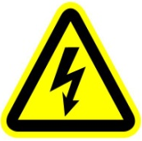  Electrical shock |   Goggles |   Protective Gloves | 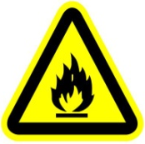  Flames | 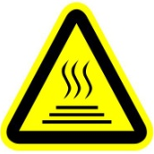  High Temperature

 | ● When unpacking , check if there is any damage caused by transportation before using a projector. Should there be any damage, consult your dealer and do not use it.  ● The manufacture is not responsible for any loss caused by a user not following the manual or changing a projector as he/she likes.  ● Please be noted that any damage caused by changing the projector at will is not warranted.  ● Do not hesitate to contact the dealer or the manufacturer if any questions or advice.
 | ● A projector rated for IP66 or higher can be used indoors and outdoors.  ● For a projector with lower IP class ,it is for bidden to contact with water or any other liquids directly or indirectly.  ● A projector should be kept away from high temperature, fire, electrical surge, vibration and strong light while being operated.  ● A projector is only intended for installation, operation and maintenance by a qualified person. And the operation must strictly follow the procedures in the manual.  ● A projector is not for a user to make any replacements and the user shouldn't open a projector for repair and maintenance.  
●Don’t look straightly into the light sources especially for epileptics, otherwise eyes will be burned..
●Do not connect this device to any type of dimmer pack.
● If the lamp, lens and screen protective cover of the a projector have obvious damage, i.e., to the extent that it hurts the performance like cracking or deformation, please stop using it and replace them with the original parts, otherwise its performance will be compromised.
● For the location of a projector, it shouldn’t be seen in the distance of less than 4 meters.

 | ●Before operation, please confirm that all covers(housing) are on and screws tightened. It’s forbidden to use a projector while its covers(housing)are off .  ●Keep the lamp clean and do not touch it with bare hands.  ●While operating it, wear protective items like goggle and gloves.
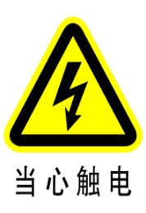 | ●Any electrical connection must be carried out by a qualified person .  ●Before installation, please confirm the voltage supplied matches what is required for a projector.  ●Each projector must be properly earthed and installed as per related electrical standards.  ●Do not use power cord with its insulator damaged and connect the power cord with other cables.  ●If a projector is not used or under cleaning,, please hold its plug and unplug it. Do not unplug it forcefully or by pulling the power cable.  ●All power cords must conform to related safety and regulations.  ●While being operated, if a projector is not waterproof and dust-proof, it should not be under rains or in humidity to avoid being short.  ●Do not switch on and off a projector constantly in very short intervals, otherwise its light source’s and other electrical parts’ life will be shortened .
●There are safety cord holes at the bottom of the base of a projector. In view of safety, please run the safety cord supplied through the safety cord holes for safety support.
●Before any installation, maintenance and cleaning work, please ensure a projector is disconnected from power mains.
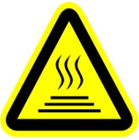 | ●While being in stable working state under normal ambient temperature, the temperature of the surface of the metallic housing of a projector including heat sink will reach 75℃.  ●While its lamp is stricken for the first time, there will be smoke and strange smell. It’s normal and does not mean a projector has some defects.  ●While a projector running, do not touch the metallic housing to avoid being burned.
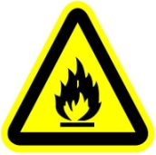 | ●Do not mount a projector directly on inflammable surface.  ●Do not project the beam straightly on combustible items and the minimum distance between it  and illuminated items is 10m.  ●A projector should be installed with good ventilation and the minimum distance between it and walls is 50cm. At the same time, please ensure the fans and air inlets and outlets are workable.  ●Do not let the front lens expose to sunlight or other strong light sources at any angle, otherwise the focused beam inside can result in fire potentially.

2. INSTRUCTIONS
●CLEANING AND MAINTENANCE

If a projector can’t start. Please check if the fuse is blown up. If it does, replace it with a new fuse with same ratings. And it has over-temperature protective device. If the temperature is too high, the protective device will be triggered to shut it off. When it happens, please check if the fans run normally or fan shield is blocked by dust. After the issue is solved, restart it.

The accumulation of oil, smoke and dust on the lens will compromise the light output. Cleaning a projector is very necessary to ensure a reliable use of it. Cooling fans need to be cleaned every 15days. Internal lens, reflector and hot mirror need to be cleaned periodically to optimize light output.

Cleaning frequency is to be decided by operations and its environment. Use soft cloth and normal detergent for glass for cleaning work. It’s advised external optical system be cleaned every 20days and internal optical systems every 30/60days. Keep lens clean and do not touch optical parts with bare hands.

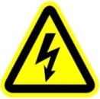 | ●Before any maintenance and cleaning, please ensure a project is off the power.  ●Only a qualified person is allowed to do maintenance.  ●During maintenance and before maintenance, a projector must be off power.
 | ●To avoid sunlight or other light penetrating into the head via the front lens, resulting in high temperature internally causing damages to a projector. Before power-off, please use Tilt channel to move the head and make it facing downward.  ● Do not use alcohol or other organic solvent to clean the housing to avoid damage.  ● Do not use any solvent with chemical elements to clean color filters or hot mirror.

SPECIAL NOTE

While water-proof projectors are in use, it’s normal there will be some minor mist on the front lens.

●LUBRICATION
To ensure smooth movement of gobos and zoom and focus lens, it’s advised rotators’ bearings and 2 sliding bars for zoom and focus lens be lubricated every 2 months. High quality and high temperature lubricant/grease is advised..
●TROUBLESHOOTING
PROBLEM | ACTION
A projector can’t be switched on | - Check if the fuse is burned  - Check if the power cord is connected well  - Check if the switching power supply is bad or not connected well. A professional technician is required for the repair  - Check if the control board is connected well. .A professional technician is required for the repair
A projector can be switched on , but the LED lamp’s brightness can’t be controlled | - Check if the LED driver board is connected well. A professional technician is required for the repair
A projector can be switched on normally, but not controlled by the DMX controller | - Make sure that its start address is right  - Replace or repair the XLR signal cable.
The beam is not bright and its brightness decreases sharply | - Make sure the fans are working well or fans and their shields are not blocked by dust.  - Make sure that the internal optics are clean.
A project image appears to have a halo | - Carefully clean the LED lamp, optical lenses and other components.
Heavily Defective Beam | - Check if lens are in good condition(not cracked)  - Clean dust or grease on the lens.

- INSTALLATION

●PLACED ON A FLAT SURFACE

While placing a projector on a flat surface, tighten the head after loosening its screw and adjusting its angle till desired. For the version with wireless control, while it is on a flat surface its antenna should face upward.

NOTE
It’s advised to use hexagon screws coupled with anti-slipping washers to ensure firm installation. Whatever screws may be used, they should not be less than 2 pairs.

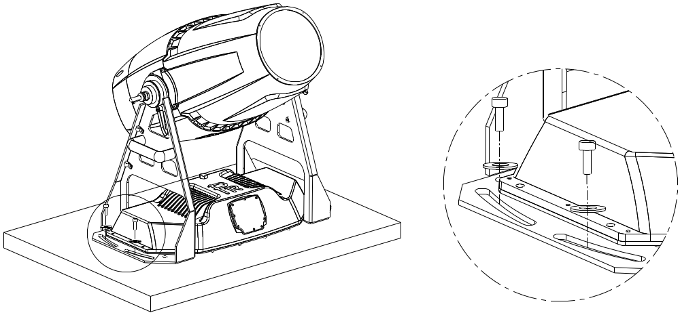

The size of the screws are to be decided by the customer based on the size of mounting holes in the arms, the following sizes in the table are only for reference.

NO | NAME | SIZE | QTY | REMARKS
1 | Hexagon screws | M12 | 8
2 | Washer | Coupled with the screws | 8

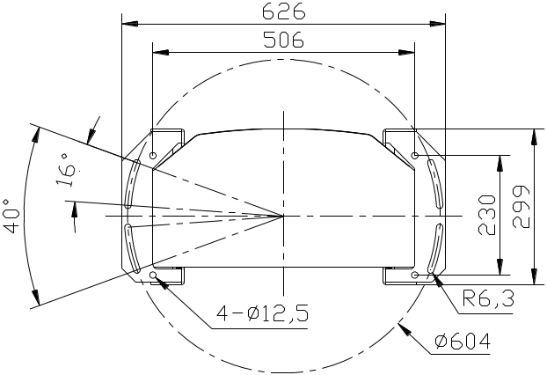

● POWER CONNECTION

Connect the power cord as follows:
L (live) =brown
E (earth) =yellow/green
N (neutral) =blue

Before power connection, please ensure the power supplied must match what the nameplate says. It is recommended that each projector be connected with power separately so that they may be individually switched on and off.

●The earth wire(yellow/green) must be connected to the ground. And electrical connection must be in accordance with the standards concerned.
●If any questions about the electrical installation, do not continue but consult a qualified electrician.
●A projector uses naked wires. For wiring please use waterproof junction box with IP class not lower than IP66.

● THE WIRING OF CONTROL SIGNAL

The colors of signal wires responds to their respective functions:

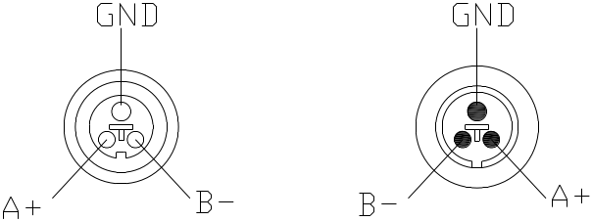
Blue --- A+
White --- B-
Shied wire ---GND
Wires with different colors inside the XLR cable and their respective functions
Male Connector
Female Connector

The shielded 2-core wire between a projector and a controller or between projectors should be not less than 0.5mm in diameter and the maximum number of projectors in a DMX chain should be less than 32 pieces.

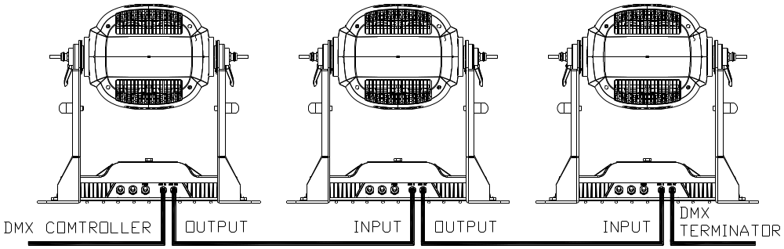

●DMX TERMINATOR

In the Controller mode, at the last fixture in the chain, its female DMX output has to be connected with a DMX terminator.
The DMX terminator is simply a Canon connector with a 120Ω (ohm) resistor connected across pin A+ and pin B-, which prevents electrical noise from disturbing and corrupting the DMX control signals. Before DMX terminator connection, please make proper insulation and waterproof treatment. . The connections are illustrated below.

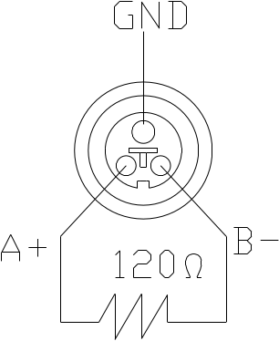

●GOBO FILTER REPLACEMENT

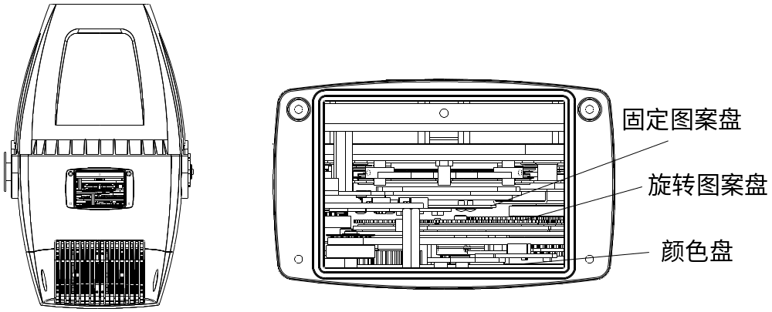
Color wheel
Rotating gobo wheel
Fixed gobo wheel

Lock the tilt and loosen the 4 fast-fit screws on the upper cover ,After removing the cover, you will see the structures as the figure above.
To replace a gobo on the rotating gobo wheel: take the rotator from the wheel in the sequence of 1→2 , take the gobo out from the rotator by removing the tightening spring. Put the new gobo back to the rotator, then tighten it with the spring. Please ensure the spring is in the narrow location of the rotator, which is the internal ring of it and flatten it. At last, pull up the spring strip using proper tool and put the rotator back to the wheel with the assistance by another hand. Its installation is of the opposite sequence of removal(（2→1）.

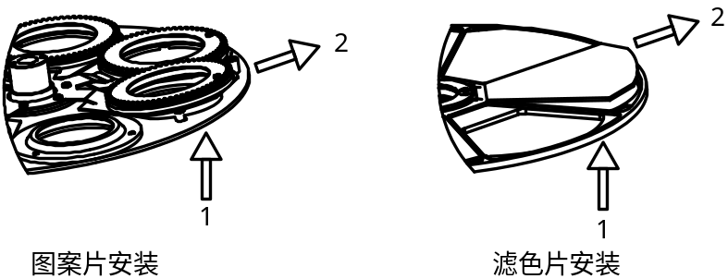

Installation of gobos

NOTE: Do not touch the glass gobo with bare hand. Place clean and soft paper or cloth between hand and glass gobos.
Tighten 4 hexagon screws after the cover is on. Unlock the tilt.

●FIXING THE FRAMING MODULE

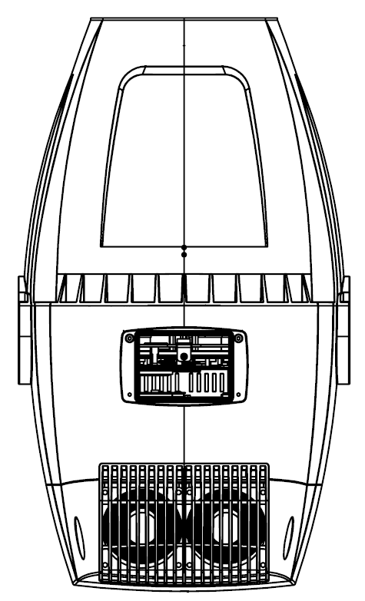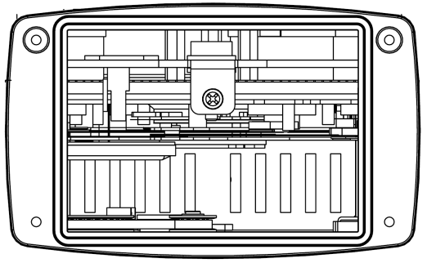
Tightening screw for module rotation
Plug

Remove the small cover after locking Tilt after adjusting the framing blades. Unplug the plug on the left after tightening the screw against the module till it can’t move . At last, install the small cover.

If the framing blades need to be adjusted, plug the plug into its original place after loosening the tightening screw, then repeat Step 1.

DANGER!

BEFORE REPLACEMENT OF GOBOS/COLOR FILTERS, A PROJECTOR MUST BE OFF THE POWER!

- SETUP AND CONFIGURATION

●FRONT PANEL OPERATION

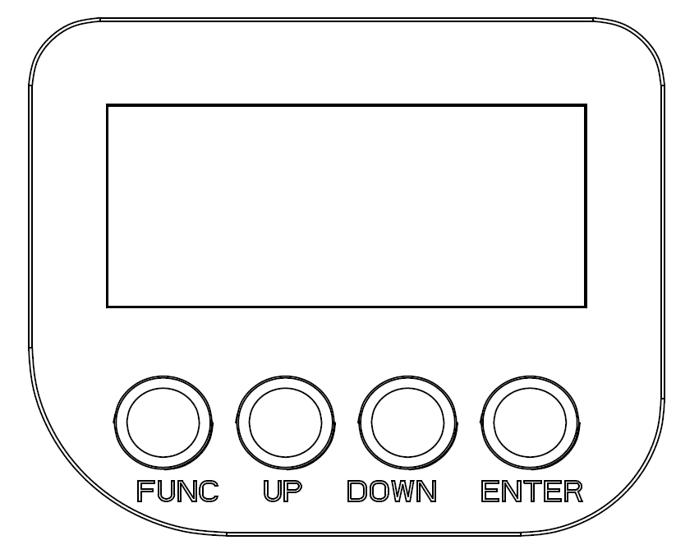
A projector’s configuration can be set conveniently via push button and LCD display.
Launch the projector and press button ENTER for more than 5 seconds to unlock the panel, the LCD will show the function menu of the projector, each main menu has its submenus and each submenu has a specific function. For details, please see the “OPERATION MENU” section.
To set up or browse through its functions, press button UP or DOWN
Press button ENTER to save your settings or enter the submenu.
Press button UP or DOWN to change values(plus or minus)
Press button FUNC, it will return to the upper menu. If button FUNC not pressed, the default will show display status automatically.

● DMX START ADDRESS
Each unit must be given a DMX start address so that the correct projector responds to the correct control signals. This DMX start address is the channel number from which the projector starts to “listen” to the digital control information being sent out from the controller. The unit has 3 DMX modes. There are standard mode ,short mode and extended mode. For example standard mode has 31channels, so set the No. 1 projector’s address 001, No. 2 projector’s address 032, No. 3 projector’s address 063, No. 4 projector’s address094, and so on.
Launch the projector. Press button ENTER more than 5seconds to unlock panel.
Press button ENTER to display DMX address;
Press button UP and DOWN, you can set the address;
Press button ENTER to confirm; after powered on next time, the default will be last value saved
Press button FUNC, it will return to the upper menu
.
●STAND-ALONE MODE
Operate the projector without connecting with a controller, enable the master mode through the operation panel, the projector will run in Stand-Alone mode automatically.
DMX address can be set at any number within 512.

●MASTER/SLAVE MODE
Many projectors can run synchronously in the Master/Slave mode by linking them with each other. First,
connect the first fixture’s DMX output to the second fixture’s DMX input using XLR-XLR control cable and then connect the second fixture’s DMX output to the third fixture’s DMX input, and so on until all projector are connected in this way. Eventually connect the last fixture’s DMX output to a DMX terminator. Set 1st projector as the master and others are Slaves. It’s advised thatthe maximum quantity of projectors in a DMX chain is less than 32.

Start Addresses of all Slaves are 001; Operation mode of the Master can be set any mode for a Master’ and Slaves’ operation mode can be set accordingly.

After Powered on, the group will run in Master/Slave Mode

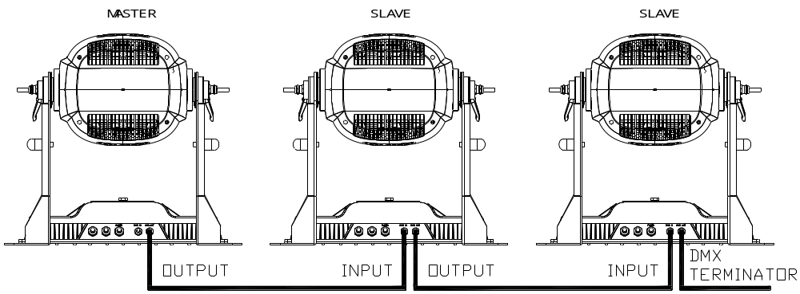

- OPERATION MENU

1st LEVEL | 2nd LEVEL | 3rd LEVEL | 4th LEVEL | 5th LEVEL
Product model
DMX address
Signal Mode
Channel mode
DMX setting | DMX Address | Short Mode:1-485  Standard Mode:1-482  Extended Mode:1-67
Reset | Total Reset | Really Reset? | Confirm/Cancel
Reset | Colour System | Really Reset? | Confirm/Cancel
Reset | Gobo Reset | Really Reset? | Confirm/Cancel
Reset | Zo.Fo. Pr. | Really Reset? | Confirm/Cancel
Reset | Other Reset | Really Reset? | Confirm/Cancel
Config Set | Channel Mode | Short 28CH
Config Set | Channel Mode | Standard 31CH
Config Set | Channel Mode | Extended 46CH
Config Set | Channel Mode | View Mode | 001 Strobe  …
Config Set | Signal Select | XLR Only
Config Set | Signal Select | XLR First
Config Set | Signal Select | Wireless Only
Config Set | Signal Select | Wireless First
Config Set | Signal Select | Wireless XLR
Config Set | Loss of DMX | Normal timeout
Config Set | Loss of DMX | Hold Last
Config Set | Disp. Config | Display Mode | Off Delay
Config Set | Disp. Config | Display Mode | On Always
Config Set | Disp. Config | Display Inv | Invert OFF
Config Set | Disp. Config | Display Inv | Invert ON
Config Set | Disp. Config | Language Set | English
Config Set | Disp. Config | Language Set | Chinese
Config Set | Temp. Unit | Celsius
Config Set | Temp. Unit | Fahrenheit
Config Set | Un-Link WDMX | Really Un-Link? | Confirm/Cancel
Config Set | Factory Reset | Factory Reset | Confirm/Cancel
Option Set | Invert Set | Zoom Inv. | OFF/ ON
Option Set | Invert Set | CYM Inv. | OFF/ ON
Option Set | Invert Set | CTO Inv. | OFF/ ON
Option Set | Dimmer Set | Gamma Curve | Gamma 2.0/2.2/2.4/2.6
Option Set | Dimmer Set | LED Ref. Rate | 1200/2400/4800/10000/12000/15000/20000/25000Hz
Option Set | Dimmer Set | Dimmer Speed | Fast/Medium/Slow Speed
Option Set | Fan Set | Standard/Theatre
Option Set | Blade Detect | Detect Disable/ Detect Enable
Information | View DMX | Strobe XXX  Dimmer XXX  Dimmer F XXX  CMY Macro XXX  Cyan XXX  Yellow XXX  Magenta XXX  CTO XXX  Colour XXX  Colour F XXX  FGobo XXX  RGobo XXX  RGobo R XXX  RGobo RF XXX  Flade 1 A XXX  Flade 1 B XXX  Flade 2 A XXX  Flade 2 B XXX  Flade 3 A XXX  Flade 3 B XXX  Flade 4 A XXX  Flade 4 B XXX  Flade R XXX  Prism XXX  Prism R XXX  Effect XXX  Effect R XXX  Frost XXX  Focus XXX  Zoom XXX  Pow/Sp Fun XXX.
Information | Total Hours | XXXXH
Information | Temperature | Display XXX
Information | Temperature | Driver 1 XXX
Information | Temperature | Driver 2 XXX
Information | Temperature | Driver 3 XXX
Information | Temperature | Driver 4 XXX
Information | Temperature | Fan board XXX
Information | Temperature | LED XXX
Information | Software Ver. | Display | XXX
Information | Software Ver. | Driver 1 | XXX
Information | Software Ver. | Driver 2 | XXX
Information | Software Ver. | Driver 3 | XXX
Information | Software Ver. | Driver 4 | XXX
Information | Software Ver. | Fan Board | XXX
Information | Elect SN | Elect SN=  ************
Information | RDM Label | ANSI E1.20 RDM  TANGO 1800 FRAMING
Information | Fan Status | Head Fan XXX×/√
Service | Manual Ctrl | Strobe XXX  Dimmer XXX  Dimmer F XXX  CMY Macro XXX  Cyan XXX  Cyan F XXX  Yellow XXX  Yellow F XXX  Magenta XXX  Magenta F XXX  CTO XXX  CTO XXX  Colour XXX  Colour F XXX  FGobo XXX  RGobo XXX  RGobo R XXX  RGobo RF XXX  Flade 1 A XXX  Flade 1 AF XXX  Flade 1 B XXX  Flade 1 BF XXX  Flade 2 A XXX  Flade 2 AF XXX  Flade 2 B XXX  Flade 2 BF XXX  Flade 3 A XXX  Flade 3 AF XXX  Flade 3 B XXX  Flade 3 BF XXX  Flade 4 A XXX  Flade 4 AF XXX  Flade 4 B XXX  Flade 4 BF XXX  Flade R XXX  Flade RF XXX  Prism XXX  Prism R XXX  Effect XXX  Effect R XXX  Frost XXX  Focus XXX  Focus F XXX  Zoom XXX  Zoom F XXX.
Service | Factory Test
Operation | DMX Mode | Change Mode? | Confirm/Cancel
Operation | Master Mode | Preset Memory | Change Mode? | Confirm/Cancel
Operation | Master Mode | User Memory 1 | Change Mode? | Confirm/Cancel
Operation | Master Mode | User Memory 2 | Change Mode? | Confirm/Cancel
Operation | Stand-Alone | Preset Memory | Change Mode? | Confirm/Cancel
Operation | Stand-Alone | User Memory 1 | Change Mode? | Confirm/Cancel
Operation | Stand-Alone | User Memory 2 | Change Mode? | Confirm/Cancel
Operation | Static Scene | Change Mode? | Confirm/Cancel
User Memory | Edit Memory | Edit Memory 1  /Edit Memory 2 | Scene XX  （1~16 Scenes） | Strobe XXX  Dimmer XXX  Dimmer F XXX  CMY Macro XXX  Cyan XXX  Cyan F XXX  Yellow XXX  Yellow F XXX  Magenta XXX  Magenta F XXX  CTO XXX  CTO XXX  Colour XXX  Colour F XXX  FGobo XXX  RGobo XXX  RGobo R XXX  RGobo RF XXX  Flade 1 A XXX  Flade 1 AF XXX  Flade 1 B XXX  Flade 1 BF XXX  Flade 2 A XXX  Flade 2 AF XXX  Flade 2 B XXX  Flade 2 BF XXX  Flade 3 A XXX  Flade 3 AF XXX  Flade 3 B XXX  Flade 3 BF XXX  Flade 4 A XXX  Flade 4 AF XXX  Flade 4 B XXX  Flade 4 BF XXX  Flade R XXX  Flade RF XXX  Prism XXX  Prism R XXX  Effect XXX  Effect R XXX  Frost XXX  Focus XXX  Focus F XXX  Zoom XXX  Zoom F XXX.  Fade Time XXX  Hold time XXX  Delay Time XXX  Delay unit (msec/s/m)  Next Step XXX
User Memory | Edit Memory | Edit Scene | Paste?  Confirm | Strobe XXX  Dimmer XXX  Dimmer F XXX  CMY Macro XXX  Cyan XXX  Cyan F XXX  Yellow XXX  Yellow F XXX  Magenta XXX  Magenta F XXX  CTO XXX  CTO XXX  Colour XXX  Colour F XXX  FGobo XXX  RGobo XXX  RGobo R XXX  RGobo RF XXX  Flade 1 A XXX  Flade 1 AF XXX  Flade 1 B XXX  Flade 1 BF XXX  Flade 2 A XXX  Flade 2 AF XXX  Flade 2 B XXX  Flade 2 BF XXX  Flade 3 A XXX  Flade 3 AF XXX  Flade 3 B XXX  Flade 3 BF XXX  Flade 4 A XXX  Flade 4 AF XXX  Flade 4 B XXX  Flade 4 BF XXX  Flade R XXX  Flade RF XXX  Prism XXX  Prism R XXX  Effect XXX  Effect R XXX  Frost XXX  Focus XXX  Focus F XXX  Zoom XXX  Zoom F XXX.
User Memory | Init Memory | Reset Memory 1 | Confirm/Cancel | Input Password123
User Memory | Init Memory | Reset Memory 2 | Confirm/Cancel | Input Password123
User Memory | Init Memory | Reset Static Scene | Confirm/Cancel | Input Password123

- DMX PROTOCOL

Short mode | Standard mode | Extended mode | Description | Decimal low | Decimal High
1 | 1 | 1 | Strobe
1 | 1 | 1 | Close | 0
1 | 1 | 1 | Pulse strobe from slow to fast | 1 | 127
1 | 1 | 1 | Strobe from slow to fast | 128 | 225
2 | 2 | 2 | Dimmer
2 | 2 | 2 | Close | 0 | 0
2 | 2 | 2 | Linear dimmer (0-100%) | 1 | 255
 | 3 | 3 | Dimmer in 16 bit
 | 3 | 3 | Dimmer in 16 bit adjustment | 0 | 255
3 | 4 | 4 | CYM macros
 |  |  | The following functions will disable CMY,CTO, color wheel
 |  |  | No function | 0 | 9
 |  |  | Color macro1 | 10 | 11
 |  |  | Color macro2 | 12 | 13
 |  |  | Color macro3 | 14 | 15
 |  |  | Color macro4 | 16 | 17
 |  |  | Color macro5 | 18 | 19
 |  |  | Color macro6 | 20 | 21
 |  |  | Color macro7 | 22 | 23
 |  |  | Color macro8 | 24 | 25
 |  |  | Color macro9 | 26 | 27
 |  |  | Color macro10 | 28 | 29
 |  |  | Color macro11 | 30 | 31
 |  |  | Color macro12 | 32 | 33
 |  |  | Color macro13 | 34 | 35
 |  |  | Color macro14 | 36 | 37
 |  |  | Color macro15 | 38 | 39
 |  |  | Color macro16 | 40 | 41
 |  |  | Color macro17 | 42 | 43
 |  |  | Color macro18 | 44 | 45
 |  |  | Color macro19 | 46 | 47
 |  |  | Color macro20 | 48 | 49
 |  |  | Color macro21 | 50 | 51
 |  |  | Color macro22 | 52 | 53
 |  |  | Color macro23 | 54 | 55
 |  |  | Color macro24 | 56 | 57
 |  |  | Color macro25 | 58 | 59
 |  |  | Color macro26 | 60 | 61
 |  |  | Color macro27 | 62 | 63
 |  |  | Color macro28 | 64 | 65
 |  |  | Color macro29 | 66 | 67
 |  |  | Color macro30 | 68 | 69
 |  |  | Color macro31 | 70 | 71
 |  |  | Color macro32 | 72 | 73
 |  |  | Color macro33 | 74 | 75
 |  |  | Color macro34 | 76 | 77
 |  |  | Color macro35 | 78 | 79
 |  |  | Color macro36 | 80 | 81
 |  |  | Color macro37 | 82 | 83
 |  |  | Color macro38 | 84 | 85
 |  |  | Color macro39 | 86 | 87
 |  |  | Color macro40 | 88 | 89
 |  |  | Color macro41 | 90 | 91
 |  |  | Color macro42 | 92 | 93
 |  |  | Color macro43 | 94 | 95
 |  |  | Color macro44 | 96 | 97
 |  |  | Color macro45 | 98 | 99
 |  |  | Color macro46 | 100 | 101
 |  |  | Color macro47 | 102 | 103
 |  |  | Color macro48 | 104 | 105
 |  |  | Color macro49 | 106 | 107
 |  |  | Color macro50 | 108 | 109
 |  |  | Color macro51 | 110 | 111
 |  |  | Color macro52 | 112 | 113
 |  |  | Color macro53 | 114 | 115
 |  |  | Color macro54 | 116 | 117
 |  |  | Color macro55 | 118 | 119
 |  |  | Color macro56 | 120 | 121
 |  |  | Color macro57 | 122 | 123
 |  |  | Color macro58 | 124 | 125
 |  |  | Color macro59 | 126 | 127
 |  |  | Color macro60 | 128 | 129
 |  |  | Color macro61 | 130 | 131
 |  |  | Color macro62 | 132 | 133
 |  |  | Color macro63 | 134 | 135
 |  |  | Color macro64 | 136 | 137
 |  |  | Color macro65 | 138 | 139
 |  |  | Color macro66 | 140 | 141
 |  |  | Color macro67 | 142 | 143
 |  |  | Color macro68 | 144 | 145
 |  |  | Color macro69 | 146 | 147
 |  |  | Color macro70 | 148 | 149
 |  |  | Color macro71 | 150 | 151
 |  |  | Color macro72 | 152 | 153
 |  |  | Color macro73 | 154 | 155
 |  |  | Color macro74 | 156 | 157
 |  |  | Color macro75 | 158 | 159
 |  |  | Color macro76 | 160 | 161
 |  |  | Color macro77 | 162 | 163
 |  |  | Color macro78 | 164 | 165
 |  |  | Color macro79 | 166 | 167
 |  |  | Color macro80 | 168 | 169
 |  |  | Color macro81 | 170 | 171
 |  |  | Color macro82 | 172 | 173
 |  |  | Color macro83 | 174 | 175
 |  |  | Color macro84 | 176 | 177
 |  |  | Color macro85 | 178 | 179
 |  |  | Color macro86 | 180 | 181
 |  |  | Color macro87 | 182 | 183
 |  |  | Color macro88 | 184 | 185
 |  |  | Color macro89 | 186 | 187
 |  |  | Color macro90 | 188 | 189
 |  |  | Color macro91 | 190 | 191
 |  |  | Color macro92 | 192 | 193
 |  |  | Color macro93 | 194 | 195
 |  |  | Color macro94 | 196 | 197
 |  |  | Color macro95 | 198 | 199
 |  |  | CMY color mixing fade from slow toast | 200 | 255
4 | 5 | 5 | Cyan
4 | 5 | 5 | Cyan (Linear 0-100%) | 0 | 255
 |  | 6 | Cyan in 16 bit
 |  | 6 | Cyan 16 bit adjustment | 0 | 255
5 | 6 | 7 | Yellow
5 | 6 | 7 | Yellow (Linear 0-100%) | 0 | 255
 |  | 8 | Yellow in 16 bit
 |  | 8 | Yellow 16bit adjustment | 0 | 255
6 | 7 | 9 | Magenta
6 | 7 | 9 | Magenta (Linear 0-100%) | 0 | 255
 |  | 10 | Magenta in 16bit
 |  | 10 | Magenta 16 bit adjustment | 0 | 255
7 | 8 | 11 | CTO
7 | 8 | 11 | Linear CTO from high t low | 0 | 255
 |  | 12 | CTO in 16 bit
 |  | 12 | CTO 16 bit adjustment | 0 | 255
8 | 9 | 13 | Color wheel
8 | 9 | 13 | Continuous positioning
8 | 9 | 13 | Indexing 0-360° | 0 | 63
8 | 9 | 13 | Positioning
8 | 9 | 13 | Open | 64 | 67
8 | 9 | 13 | Open /Color1 | 68 | 71
8 | 9 | 13 | Color 1 | 72 | 75
8 | 9 | 13 | Color1/Color2 | 76 | 79
8 | 9 | 13 | Color2 | 80 | 83
8 | 9 | 13 | Color2/Color3 | 84 | 87
8 | 9 | 13 | Color3 | 88 | 91
8 | 9 | 13 | Color3/Color4 | 92 | 95
8 | 9 | 13 | Color4 | 96 | 99
8 | 9 | 13 | Color4/Color5 | 100 | 103
8 | 9 | 13 | Color5 | 104 | 107
8 | 9 | 13 | Color5Color6 | 108 | 111
8 | 9 | 13 | Color6 | 112 | 115
8 | 9 | 13 | Color6 /Open | 116 | 119
8 | 9 | 13 | Open | 120 | 127
8 | 9 | 13 | Clockwise rainbow effect from slow to fast | 128 | 191
8 | 9 | 13 | Anti-clockwise rainbow effect from slow to fast | 192 | 255
 | 10 | 14 | Color wheel in 16bit
 | 10 | 14 | Color wheel continuous positioning ,16bit adjustment | 0 | 255
9 | 11 | 15 | Fixed gobo wheel
9 | 11 | 15 | Open | 0 | 16
9 | 11 | 15 | Gobo1 | 17 | 31
9 | 11 | 15 | Gobo2 | 32 | 47
9 | 11 | 15 | Gobo3 | 48 | 63
9 | 11 | 15 | Gobo4 | 64 | 79
9 | 11 | 15 | Gobo5 | 80 | 95
9 | 11 | 15 | Gobo6 | 96 | 111
9 | 11 | 15 | Gobo7 | 112 | 127
9 | 11 | 15 | Clockwise rainbow effect from slow to fast | 128 | 149
9 | 11 | 15 | Anti-clockwise rainbow effect from slow to fast | 150 | 171
9 | 11 | 15 | Gobo1 shake from slow to fast | 172 | 183
9 | 11 | 15 | Gobo2 shake from slow to fast | 184 | 195
9 | 11 | 15 | Gobo3 shake from slow to fast | 196 | 207
9 | 11 | 15 | Gobo4shake from slow to fast | 208 | 219
9 | 11 | 15 | Gobo5 shake from slow to fast | 220 | 231
9 | 11 | 15 | Gobo6 shake from slow to fast | 232 | 243
9 | 11 | 15 | Gobo7shake from slow to fast | 244 | 255
10 | 12 | 16 | Rotating gobo wheel
10 | 12 | 16 | Open | 0 | 31
10 | 12 | 16 | Gobo1 | 32 | 47
10 | 12 | 16 | Gobo2 | 48 | 63
10 | 12 | 16 | Gobo3 | 64 | 79
10 | 12 | 16 | Gobo4 | 80 | 95
10 | 12 | 16 | Gobo5 | 96 | 111
10 | 12 | 16 | Gobo6 | 112 | 127
10 | 12 | 16 | Clockwise rotation from slow to fast | 128 | 143
10 | 12 | 16 | Anti-clockwise rotation from slow to fast | 144 | 159
10 | 12 | 16 | Gobo1 shakes from slow to fast | 160 | 175
10 | 12 | 16 | Gobo2 shakes from slow to fast | 176 | 191
10 | 12 | 16 | Gobo3 shakes from slow to fast | 192 | 207
10 | 12 | 16 | Gobo4shakes from slow to fast | 208 | 223
10 | 12 | 16 | Gobo5shakes from slow to fast | 224 | 239
10 | 12 | 16 | Gobo6shakes from slow to fast | 240 | 255
11 | 13 | 17 | Gobo rotation
11 | 13 | 17 | Indexing 0-360° | 0 | 128
11 | 13 | 17 | Clockwise rotation from slow to fast | 129 | 188
11 | 13 | 17 | Stop | 189 | 195
11 | 13 | 17 | Anti-clockwise rotation from slow to fast | 196 | 255
 | 14 | 18 | Gobo rotation in 16bit
 | 14 | 18 | Gobo rotation 16 bit adjustment | 0 | 255
12 | 15 | 19 | Framing blade 1left
12 | 15 | 19 | Linear Framing Blade1 Left Change 0%-100% | 0 | 255
 |  | 20 | Framing Blade 1 Left change in 16 bit
 |  | 20 | Framing Blade 1 Left change in 16 bit precision | 0 | 255
13 | 16 | 21 | Framing Blade 1 right
13 | 16 | 21 | Linear Framing Blade1 Right Change 0%-100% | 0 | 255
 |  | 22 | Framing Blade 1 right change in 16 bit
 |  | 22 | Framing Blade 1 right change in 16 bit precision | 0 | 255
14 | 17 | 23 | Framing Blade 2 Left
14 | 17 | 23 | Linear Framing Blade2 Left Change 0%-100% | 0 | 255
 |  | 24 | Framing Blade 2 Left change in 16 bit
 |  | 24 | Framing Blade 2 Left change in 16 bit precision | 0 | 255
15 | 18 | 25 | Framing Blade 2 Right
15 | 18 | 25 | Linear Framing Blade2 Right Change 0%-100% | 0 | 255
 |  | 26 | Framing Blade 2 right change in 16 bit
 |  | 26 | Framing Blade 2 right change in 16 bit precision | 0 | 255
16 | 19 | 27 | Framing Blade 3 Left
16 | 19 | 27 | Linear Framing Blade3 Left Change 0%-100% | 0 | 255
 |  | 28 | Framing Blade 3 Left change in 16 bit
 |  | 28 | Framing Blade 3Left change in 16 bit precision | 0 | 255
17 | 20 | 29 | Framing Blade 3 Right
17 | 20 | 29 | Linear Framing Blade3 Right Change 0%-100% | 0 | 255
 |  | 30 | Framing Blade 3 right change in 16 bit
 |  | 30 | Framing Blade 3right change in 16 bit precision | 0 | 255
18 | 21 | 31 | Framing Blade 4 Left
18 | 21 | 31 | Linear Framing Blade4Left Change 0%-100% | 0 | 255
 |  | 32 | Framing Blade 4 Left change in 16 bit
 |  | 32 | Framing Blade 4Left change in 16 bit precision | 0 | 255
19 | 22 | 33 | Framing Blade 4 Right
19 | 22 | 33 | Linear Framing Blade4Right Change 0%-100% | 0 | 255
 |  | 34 | Framing Blade 4 right change in 16 bit
 |  | 34 | Framing Blade 4right change in 16 bit precision | 0 | 255
20 | 23 | 35 | Framing Module rotation
20 | 23 | 35 | Framing Module Indexing(0-90degrees) | 0 | 255
20 | 23 | 36 | Framing Module rotation in 16 bit
20 | 23 | 36 | Framing Module rotation(0-90degrees) in 16 bit | 0 | 255
21 | 24 | 37 | Prism
21 | 24 | 37 | No | 0 | 16
21 | 24 | 37 | Prism in | 17 | 255
22 | 25 | 38 | Prism rotation
22 | 25 | 38 | Prism indexing | 0 | 127
22 | 25 | 38 | Stop | 128
22 | 25 | 38 | Clockwise rotation from slow to fast | 129 | 191
22 | 25 | 38 | Stop | 192
22 | 25 | 38 | Anti-clockwise rotation from slow to fast | 193 | 255
23 | 26 | 39 | Effect wheel
23 | 26 | 39 | No | 0 | 19
23 | 26 | 39 | Effect wheel in | 20 | 255
24 | 27 | 40 | Effect wheel rotation
24 | 27 | 40 | Clockwise rotation from fast to slow | 0 | 127
24 | 27 | 40 | Anti-clockwise rotation from slow to fast | 128 | 255
25 | 28 | 41 | Frost
25 | 28 | 41 | Linear frost 0% - 100% | 0 | 255
26 | 29 | 42 | Focus
26 | 29 | 42 | Linear focus | 0 | 255
 |  | 43 | Focus in 16 bit
 |  | 43 | Focus 16 bit adjustment | 0 | 255
27 | 30 | 44 | Zoom
27 | 30 | 44 | Linear Zoom | 0 | 255
 |  | 45 | Zoom in 16 bit
 |  | 45 | Zoom 16 bit adjustment | 0 | 255
28 | 31 | 46 | Power/Special function
28 | 31 | 46 | No function | 0 | 4
28 | 31 | 46 | Reserved | 5 | 19
28 | 31 | 46 | The following function must stay in the DMX range for more than 5s to activate it
28 | 31 | 46 | Display on | 20 | 24
28 | 31 | 46 | Display off | 25 | 29
28 | 31 | 46 | Reserved | 30 | 44
28 | 31 | 46 | Reserved | 45 | 46
28 | 31 | 46 | Fan standard mode | 47 | 48
28 | 31 | 46 | Fan theater mode | 49 | 50
28 | 31 | 46 | Reserved | 51 | 52
28 | 31 | 46 | Fast dimmer speed | 53 | 54
28 | 31 | 46 | Medium dimmer speed | 55 | 56
28 | 31 | 46 | Slow dimmer speed | 57 | 58
28 | 31 | 46 | Gamma curve 2.0 | 59 | 60
28 | 31 | 46 | Gamma curve 2.2 | 61 | 62
28 | 31 | 46 | Gamma curve 2.4 | 63 | 64
28 | 31 | 46 | Gamma curve 2.6 | 65 | 66
28 | 31 | 46 | LED fresh rate 1200Hz | 67 | 68
28 | 31 | 46 | LED refresh rate 2400Hz | 69 | 70
28 | 31 | 46 | LED refresh rate 4800Hz | 71 | 72
28 | 31 | 46 | LED refresh rate 10000Hz | 73 | 74
28 | 31 | 46 | LED refresh rate 12000Hz | 75 | 76
28 | 31 | 46 | LED refresh rate 15000Hz | 77 | 78
28 | 31 | 46 | LED refresh rate 20000Hz | 79 | 80
28 | 31 | 46 | LED refresh rate 25000Hz | 81 | 82
28 | 31 | 46 | Reserved | 83 | 89
28 | 31 | 46 | Reserved | 90 | 94
28 | 31 | 46 | Reserved | 95 | 99
28 | 31 | 46 | Reserved | 100 | 129
28 | 31 | 46 | Reserved | 130 | 139
28 | 31 | 46 | Reserved | 140 | 149
28 | 31 | 46 | Color system reset | 150 | 159
28 | 31 | 46 | Gobo wheel reset | 160 | 169
28 | 31 | 46 | Reserved | 170 | 179
28 | 31 | 46 | Zoom/Focus/Frost/Prism reset | 180 | 189
28 | 31 | 46 | Other（effect wheel, framing module）reset | 190 | 199
28 | 31 | 46 | Total reset | 200 | 209
28 | 31 | 46 | Reserved | 210 | 229
28 | 31 | 46 | Reserved | 240 | 255

Remarks:
- Fan errors can result in LED lamp off automatically
- DMX channel priority: CMY macro is prior to Magenta , Yellow and Cyan flags; Prism is prior to Frost

- ERROR MESSAGES
The system can detect some errors during the reset, if displayed, press ENTER button to view the error.
The error messages are as follows:

Name | Correction
Cyan | Check if wiring, positioning parts and motors are normal
Yellow | Check if wiring, positioning parts and motors are normal
Magenta | Check if wiring, positioning parts and motors are normal
CTO | Check if wiring, positioning parts and motors are normal
Color Wheel | Check if wiring, positioning parts and motors are normal
Fixed Gobo Wheel | Check if wiring, positioning parts and motors are normal
Rot. Gobo Wheel | Check if wiring, positioning parts and motors are normal
Rot. Gobo Rotation | Check if wiring, positioning parts and motors are normal
Prism | Check if wiring, positioning parts and motors are normal
Prism Rotation | Check if wiring, positioning parts and motors are normal
Focus | Check if wiring, positioning parts and motors are normal
Zoom | Check if wiring, positioning parts and motors are normal
Effect wheel | Check if wiring, positioning parts and motors are normal
Effect wheel rotation | Check if wiring, positioning parts and motors are normal
Driver 1 | Check signal wire
Driver 2 | Check signal wire
Driver 3 | Check signal wire
Driver 4 | Check signal wire
Fan Board | Check signal wire
Time IC

- TECHNICAL DATA
ELECTRIC PARAMETERS
Input voltage 100V~240V AC，50/60Hz
Input power 1100W@220V AC
1140W @ 100V AC
Maximum current 12.0 A (100V)
Power factor PF>0.9

THE SPECIFICATIONS OF THE LIGHT SOURCE
Power 800W
Color temperature 8000K
Rated life 20000hrs
CRI Ra≥70
Optional high CRI light source Ra ≥95，R9≥90
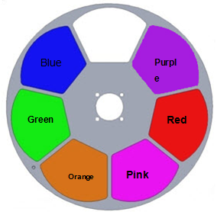
COLORS
CMY linear mixing system with macros
1 color wheel: 6exchangeable colors+ Open
Half color effect, rainbow effect with bi-directional and variable speeds,
Stepping/linear color changing

CTO
0-100% linear CTO

GOBO
1 Rotating Gobo Wheel: 6 replaceable gobos+ Open, Glass or Metal Gobo
Bi-directional Rotation with variable speeds
With Indexing Function
Gobo Shake Effect with Variable Speeds
Bi-directional Scrolling with Variable Speeds
Gobo outer size:37.5mm Gobo image size: 24mm
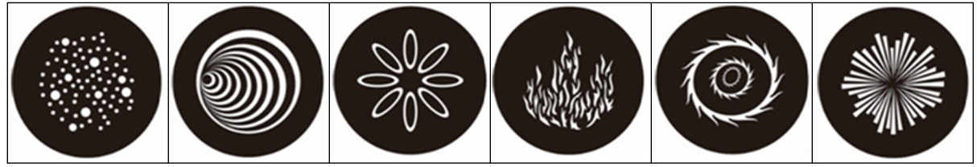
5
4
3
2
1
6

1 fixed Gobo Wheel: 7 replaceable gobos+ Open
Bi-directional Rotation with variable speeds
Gobo Shake Effect with Variable Speeds
Gobo outer size:36.3mm Gobo image size: 23mm
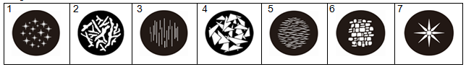
1framing module rotates between 0° and 90° and produces graphics of different shapes and sizes
4 framing blades can produce full curtain effect
PRISM
1pc of 4 facet prism , Bi-directional rotation with variable speeds and indexing function

FROST
1pc frost filter, linear frost effect( 0%-100%)
EFFECT WHEEL
1pc, replaceable, bi-directional rotation with variable speeds

FOCUS
DMX linear Focusing

DIMMER
0-100% Linear adjustment
STROBE
Double shutter blades, 0.3~25 F.P.S

TILT
270°
BEAM ANGLE
linear zoom 6°～ 56°(open)with 16 bit function

CONTROL
DMX512, 5 pin interfaces
RDM control protocol
28channels in short mode,31channels in standard mode and46channels in extended mode
Master/Slave synchronized mode
Stand-alone mode
OTHER FUNCTION
Total hours displayable
English and Chinese menus
Built-in sensor diagnostic system
Software versions displayable
Input signal isolation
Modular Structure for easy maintenance
HOUSING
High temperature ABS+ High tensile cast aluminum , IP66
NET WEIGHT
42Kg
OPERATION TEMPERATURE
-20℃～45℃
Note: If the ambient temperature is below -20°C, reset a projector before pre-heating it for more than 30 minutes
SIZES (unit: mm)
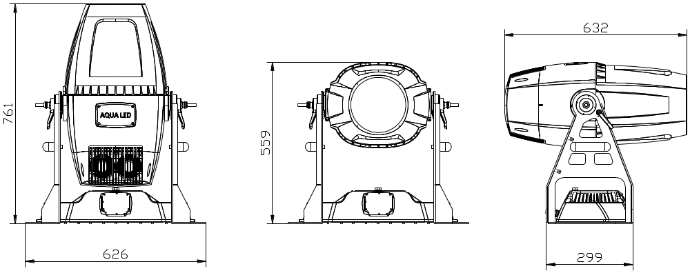
SIZE OF MOUNTING HOLES IN THE BASE (Unit mm)
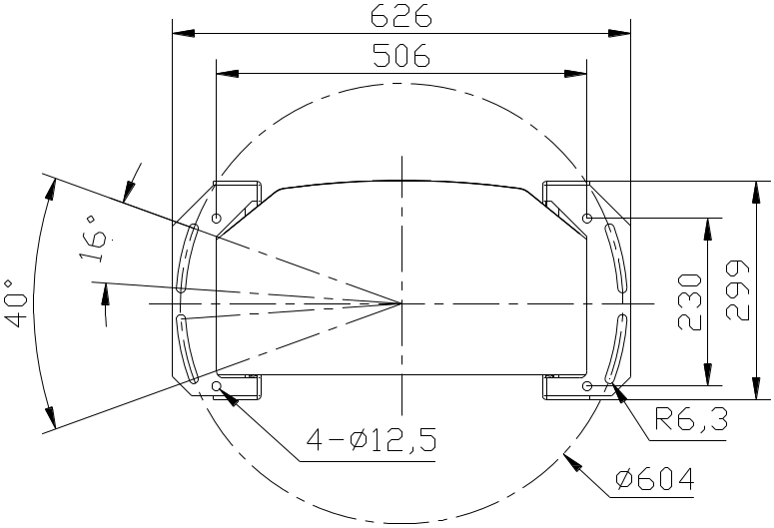

LIGHT OUTPUT:

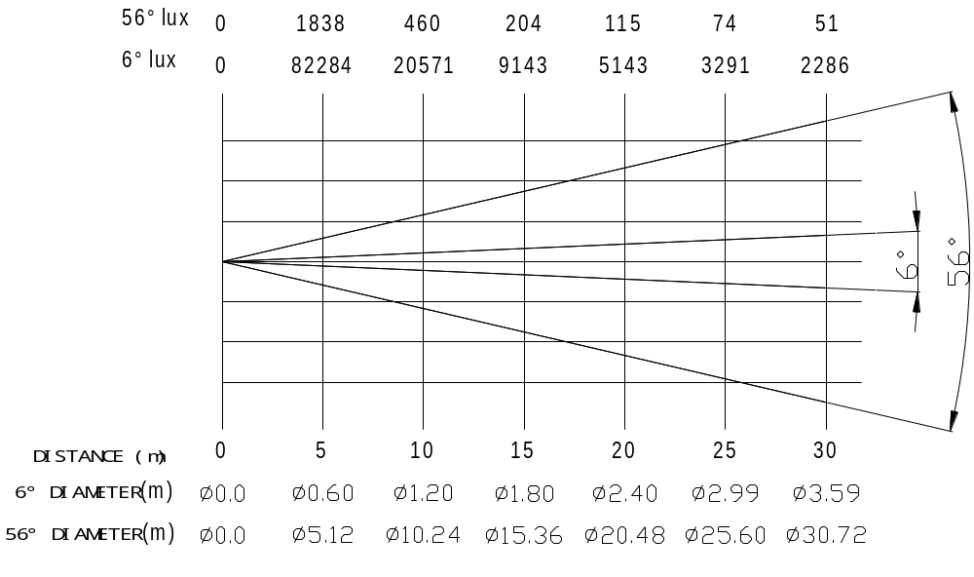

9. CIRCUIT DIAGRAM AND PCB CONNECTIONS
.CIRCUIT DIAGRAM

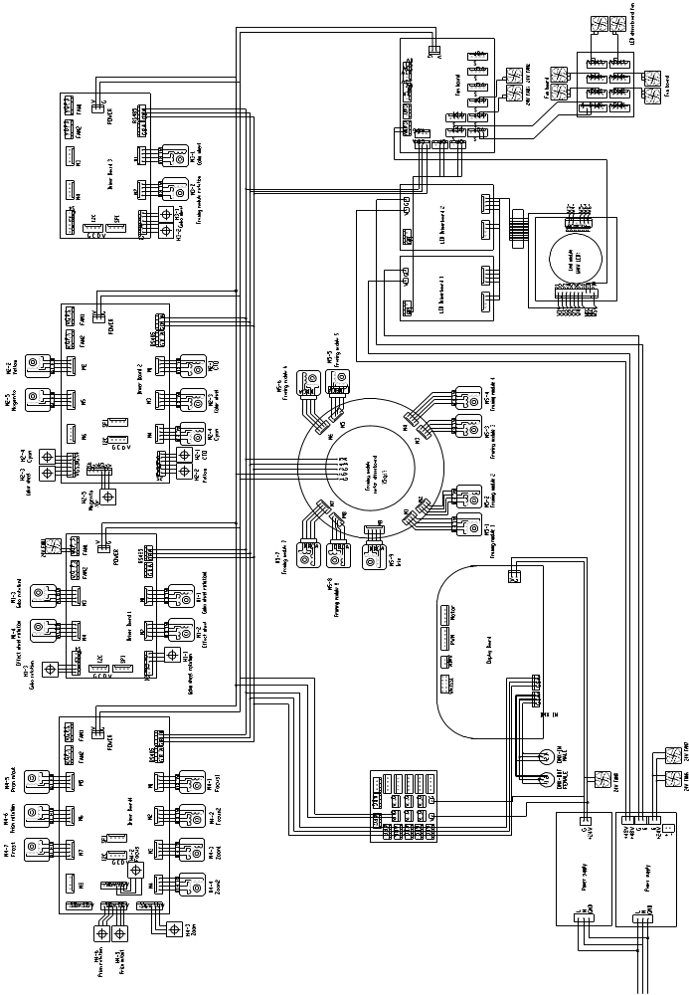
● PCB CONNECTIONS
Driver board 1

No | Name
1 | LED driver Output
2 | LED driver Output
3 | PWM Input
4 | 48V Input +
5 | 48V Input -
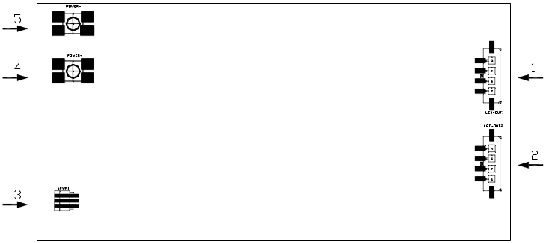

Fan board
No | Name
1-8 | Fan output with varying speeds
9 | PWM output
10 | PWM output
11-12 | 485 signal
13-15 | Reserved
16 | Thermal switch
17 | Power input
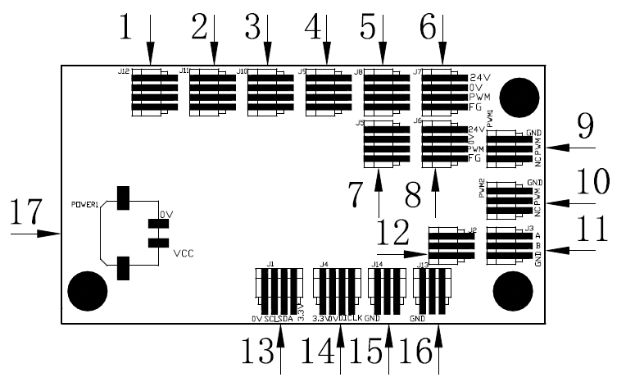

No | Name
1-2 | Zoom Motor
3-4 | Focus Motor
5 | Prism In/Out Motor
6 | Prism rotation Motor
7 | Frost Motor
8 | Reserved
9 | Magnet sensors Zoom
10 | Magnet sensors Focus
11 | Prism/Prism rotation magnet sensor
12 | Reserved
13-14 | Power Input
15 | 485 Signal fo Input
16 | 485 Signal Output
17-20 | Reserved

Driver board1

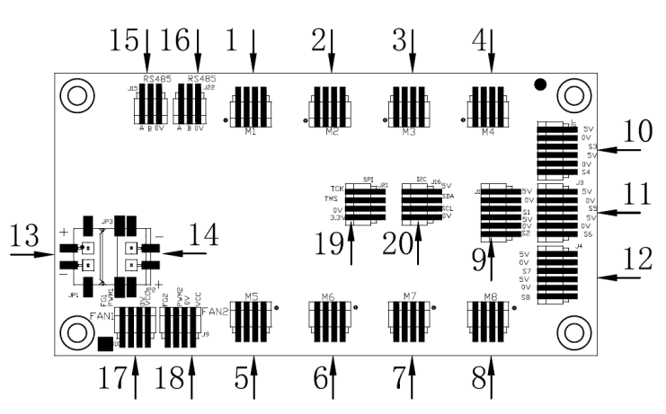

No | Name
1 | CTO Motor
2 | Colour wheel Motor
3 | Cyan Motor
4 | Yellow Motor
5 | Pink Motor
6 | Reserved
7 | Magnet sensor for CTO
8 | Magnet sensors for Colour wheel/Cyan
9 | Magnet sensors Pink
10-11 | Power Input
12 | 485 Signal Input
13 | 485 Signal Output
14-15 | Fan
16-17 | Reserved
Driver board2
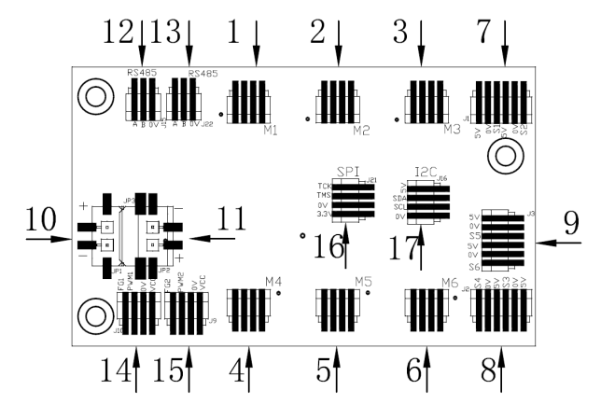

Driver board 3
No | Name
1 | Rotating gobo wheel rotation motor
2 | Effect wheel In/Out motor
3 | Gobo rotation motor
4 | Effect wheel rotation motor
5 | Rotating gobo wheel magnet sensor
6 | Gobo rotation sensor
7-8 | Power Input
9-10 | Fan
11 | 485 Signal Input
12 | 485 Signal Output
13-14 | Reserved
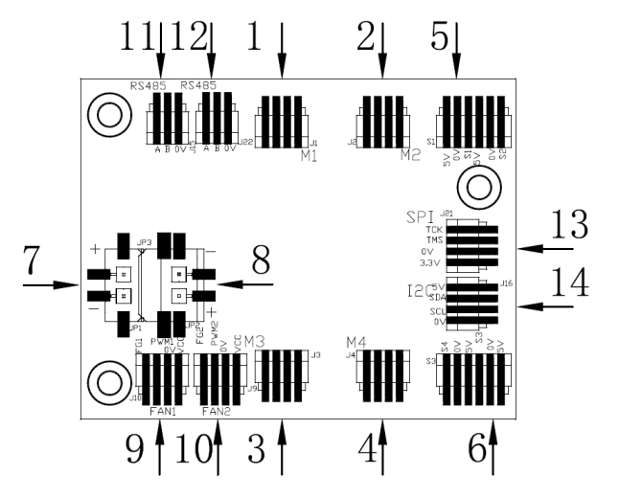

Driver board 4

No | Name
1-5 | 485 Signal
6-11 | Reserved
12 | 24V Input +
13 | 24V Input -
14-19 | 24V Output
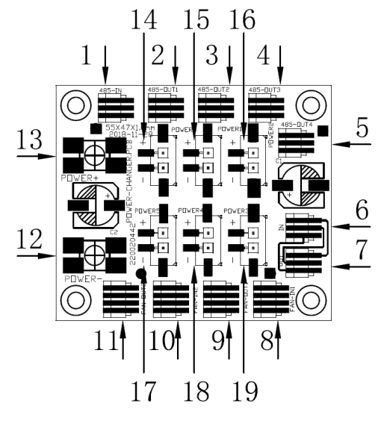
Driver board 5

No | Name
1 | Magnet sensors
2 | Framing Motor
3 | Gobo Motor
4 | 485Signal
5 | 24V Input
6-12 | Reserved
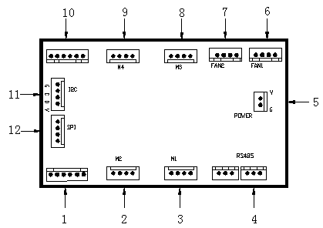

Framing module board
No | Name
1 | Framing motor2
2 | Framing motor 1
3 | Reserved
4 | Reserved
5 | Reserved
6 | Reserved
7 | Software flashing interface
8 | Reserved
9 | 24V Input
10 | Framing Motor 8
11 | Framing Motor 7
12 | Framing Motor 6
13 | Framing Motor 5
14 | Framing Motor 4
15 | Framing Motor 3

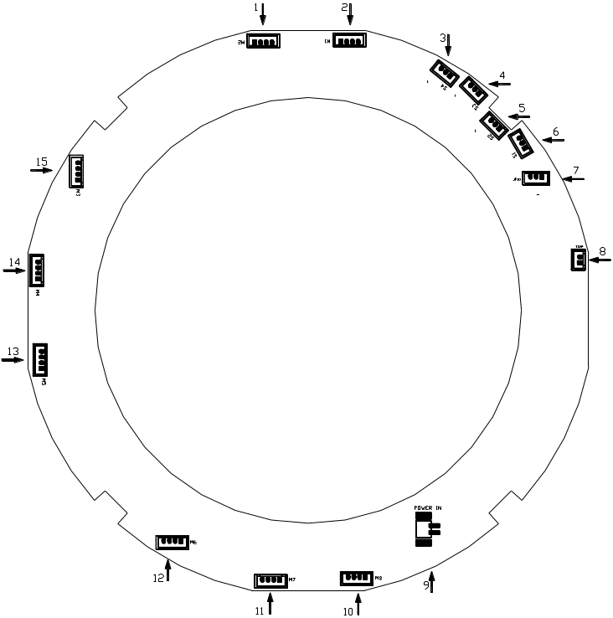

Display board
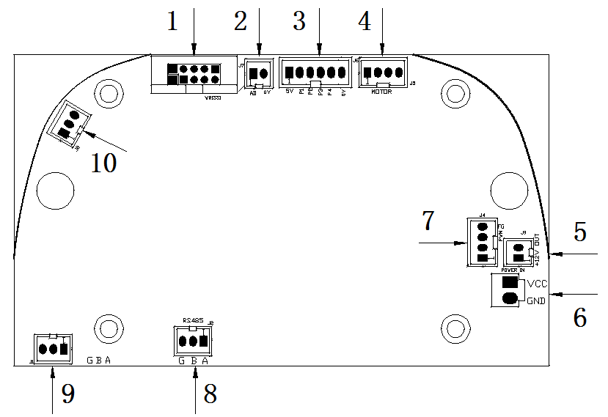
No | Name
1-5 | Reserved
6 | Power Input
7 | Fan
8 | 485 Signal
9 | DMX 512 Signal
10 | Reserved

10.COMPONENT ORDER CODES

NAME | CODE NO. | QTY. | REMARKS
SWITCHING POWER SUPPLY | 6190000014A | 1
SWITCHING POWER SUPPLY | 192010220A | 1
LED MODULE | 150020323 | 1
LED MODULE FAN | 030060109 | 4
BLOWER FOR COLOR WHEEL | 030060094A | 1
BLOWER FOR FRAMING MODULE | 030060094A | 1
FAN FOR SMALL POWER SUPPLY IN THE BASE | 030060052A | 1
LED DRIVER FAN | 030060084 | 2
FAN FOR BIG POWER SUPPLY IN THE BASE | 030060084 | 2
FAN FOR LENS ACCESSORY 8025 | 030060112 | 1
BLOWER FOR LENS ACCESSORY(ZOOM LENS ) | 030060072A | 1
FOCUS MOTOR | 030040213A | 2
ZOOM MOTOR | 030040154A | 2
PRISM MOTOR | 030040203 | 1
FROST MOTOR | 030040220A | 1
PRISM ROTATION/ROTATING GOBO WHEEL MOTOR | 030040132A | 1
GOBO ROTATION MOTOR | 030040293 | 1
EFFECT WHEEL ROTATION MOTOR | 030040060 | 1
FIXED GOBO WHEEL/COLOR WHEEL MOTOR | 030040221A | 1
EFFECT WHEEL IN/OUT MOTOR | 030040236 | 1
CMY MOTOR | 030040211A | 3
CTO MOTOR | 030040211A | 1

PR LIGHTING LTD.

1582 Xingye Avenue, Nancun Panyu
Guangzhou, 511442 China
TEL: +86-20-3995 2888

PR lighting will try its best to offer accurate and overall information about a product’s technical data. Any changes won’t be notified if necessary. Patented Products. Counterfeiting Will be Prosecuted!

P/N: 320021285

Old Version:20210416

New Version:20210511

